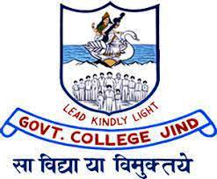

jktdh; egkfo|ky; thUn
Annual Report
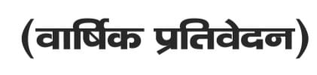

2022-23

Sh. Satyawan Malik
z izkpk;Z

egkfo|ky; dk laf{kIr ifjp;
f”k{kk fdlh jk’Vª dh jh<+ gksrh gSA f”k{kk euq’; dks nsoRo dh vksj ys tkrh gSA euq’; ds Hkhrj fodkl dh tks laHkkouk,a jgrh gSa] mUgsa fodflr djuk gh f”k{kk dk eq[; dk;Z gSA blh lksp ds ifj.kkeLo#i thUn {ks= ds lekt lsok yksxksa dh lPph fu’Bk vkSj vFkd Á;klksa ls ;g egkfo|ky; lu~ 1960 esa ifCyd dkWyst ds #i esa vfLrRo esa vk;k vkSj 50 o’kZ iwjs djus ds ckn Lo.kZ t;Urh euk pqdk gSA vkt ;g egkfo|ky; gfj;k.kk dh ,d mPpre f”k{kk laLFkku ds #i esa ifjp; ÁkIr dj pqdk gSA bl egkfo|ky; esa HkO; Hkou] fo”kky iqLrdky;] vk/kqfud Á;ksx”kkyk,a vkfn lHkh vko”;d lqfo/kk,a miyC/k gSaA bl Hkou ds ekufodh] foKku] dkWelZ] iqLrdky; vkfn pkj CykWd gSaA mPp f”k{kk Lrj] Js’B ijh{kk ifj.kke] fo|kfFkZ;ksa ds pgq¡eq[kh fodkl ds fy, fofHkUu lkaLd`frd xfrfof/k;ka] [ksy&dwn] thou ds vUryksZd dks vkyksfdr djus okyh f”k{kk] egkfo|ky; dh x.kuk fof”k’V egkfo|ky;ksa esa djk jgh gSA ÁR;sd ladk; ds vusd es/kkoh fo|kFkhZ viuh ;ksX;rk }kjk fofHkUu rduhdh vkSj Á”kklfud lsokvksa ds fy, pqus tkrs gSaA bl xfjeke;h laLFkku es Nk= Áos”k ikus ds fy, mRlqd jgrs gSaA çkpk;kZ ds dq”ky usr`Ro ,oa vko”;d fn”kk funsZ”kkas ls egkfo|ky; esa f”k{kk dk leqfpr okrkoj.k miyC/k gSA fo|kfFkZ;ksa ds fgr esa “kS{kf.kd] lkaLd`frd] oSKkfud –f’Vdks.k fodflr djus ds fy, fujarj ç;kljr gSA
EXAM BRANCH
REGISTRAR: DR.SAMSHER SINGH
egkfo|ky; esa ijh{kk “kk[kk o’kZ Hkj dk;Z djrh gSA “kk[kk us CRSUIUMS iksVZy ij fMftVy :Ik ls 2232 Nk=ksa dh fujarjrk fjVZu rS;kj dhA blus CRSUIUMS iksVZy dqy 3739 ¼fo’ke lsesLVj esa½ Nk=ksa ds ijh{kk QkWeZ Hkh tek fd,A blds ckn “kS{kf.kd o’kZ esa nks ckj vkarfjd ewY;kadu vkSj izSfDVdy ¼ vkarfjd vkSj ckgjh nksuksa½ vad Hkh mijksDr iksVZy ij tek fd, x,A ,lhvkj mn~ns”; ds fy, ifj.kkeksa dh rS;kjh “kk[kk }kjk dh xbZ FkhA blds vykok “kk[kk dh izos”k&i=] Mh,elh vkSj fMxzh ds forj.k esa lfØ; Hkwfedk gSA ;g fo”ofo|ky; ds vf/kdkfj;ksa dks Nk=ksa dh “kS{kf.kd folaxfr;ksa ds ckjs esa Hkh crkrk gSA dqy 439 Nk=ksa us viuk ikB~;Øe mrh.kZ fd;k vkSj viuh fMxzh izkIr djus ds fy, ik= ?kksf’kr fd, x,A mDr “kS{kf.kd o’kZ esa 7 Nk=ksa us usV ijh{kk mrh.kZ dhA

INTERNAL QUALITY ASSURANCE
CONVENOR: GOURAV BANSAL

1. The Internal Quality Assurance cell of the college organized a 1-day Professional development training on the E-Filing of Income Tax Returns for teaching & non-teaching staff members of the college on 13.07.2022. The programme was organized to enable staff members to file their IT returns without any help from Professional People and their hard-earned money may be saved.
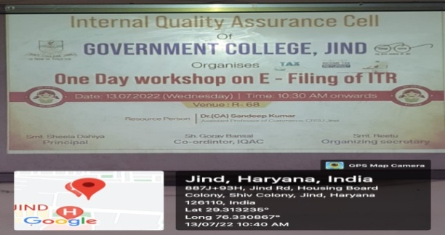
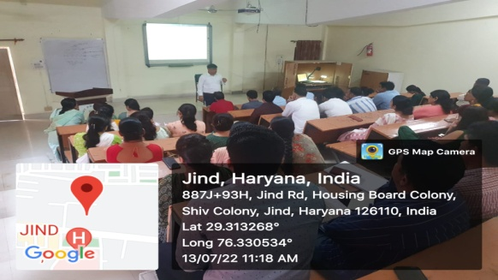
2. Internal Quality Assurance cell framed Handbook on Code of Ethics & Professional Conduct for students/teachers/other staff members. 3. Internal Quality Assurance cell has prepared the Academic cum Activity Calendar of the Institution for session 2022-23. 4. The Internal Quality Assurance cell of the college organized a one or two-day orientation programme for the newly admitted student on dated 09.09.2022.
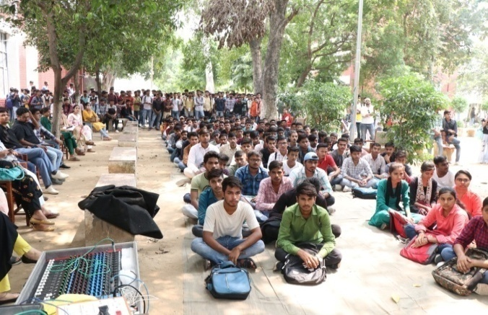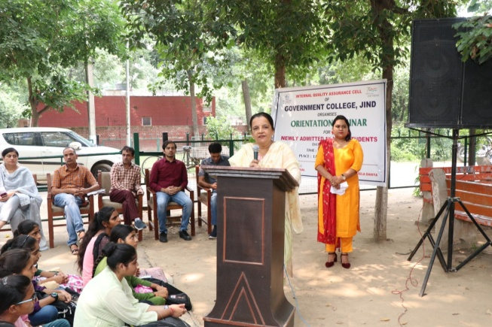
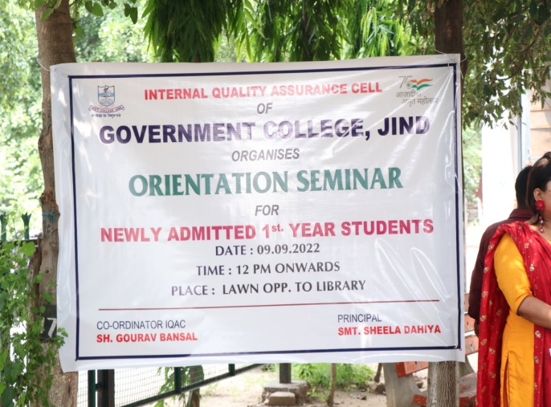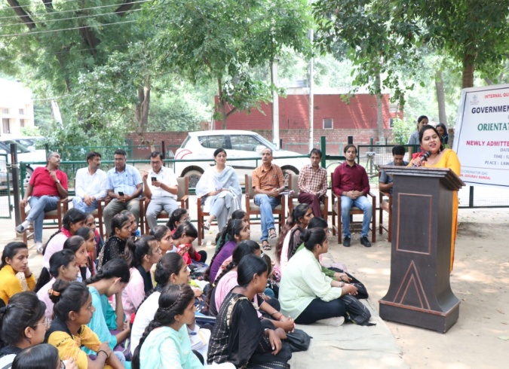
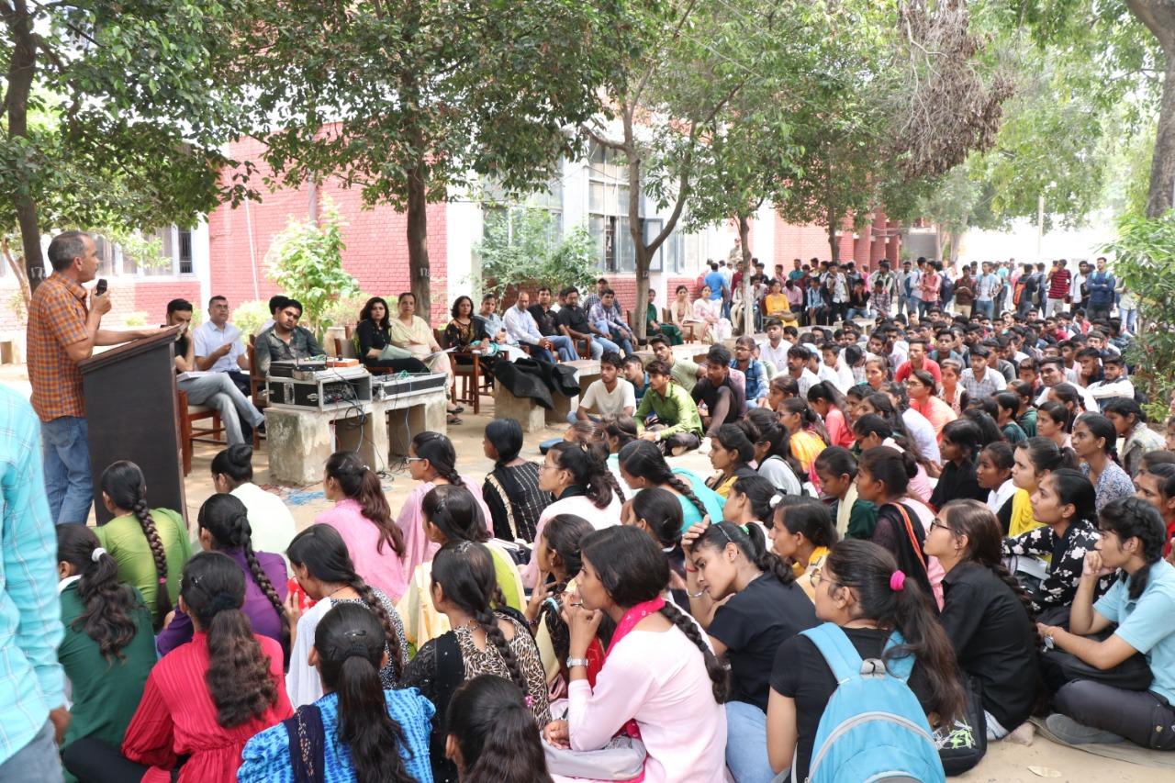
NATIONAL SERVICE SCHEME
CONVENOR: SH. SHIV KUMAR
महाविद्यालय में राष्ट्रीय सेवा योजना की III यूनिट कार्यरत हैं। प्रत्येक यूनिट में 100 वालंटियर रजिस्ट्रेशन करवाते हैं । यूनिट तीन लड़कियों के लिए है। निस्वार्थ सेवा से चरित्र निर्माण ही राष्ट्रीय सेवा योजना का लक्ष्य है।
NSS Unit | Program officer | Volunteers
Unit I | Sh. Aman | 100
Unit II | Sh. Shiv Kumar | 100
Unit III | Smt. Reetu | 100

राष्ट्रीय सेवा योजना कार्यक्रम-
- आजादी का अमृत महोत्सव कार्यक्रम के अंतर्गत पौधारोपण अभियान 14.07.2022 को चलाया गया। इसी अभियान के अंतर्गत 2 अगस्त 2022 को गांव पांडू पिंडारा में पौधारोपण कार्यक्रम किया गया।
- आजादी का अमृत महोत्सव कार्यक्रम के अंतर्गत हर घर तिरंगा साइकिल रैली का आयोजन 12 अगस्त 2022 को किया गयाI रैली की शुरुआत महाविद्यालय के मुख्य द्वार से लेकर सफीदों रोड के रास्ते एकलव्य स्टेडियम पर जाकर संपन्न हुईI
- दिनांक 15 सितंबर 2022 को राष्ट्रीय सेवा योजना यूनिट द्वारा स्वच्छता पखवाड़ा के अंतर्गत हाइजीन एंड सैनिटेशन विषय पर एक जागरूकता व्याख्यान का आयोजन किया गया।
- दिनांक 20 सितंबर 2022 को राष्ट्रीय सेवा योजना यूनिट्स द्वारा पोषण माह के अंतर्गत पोषण एवं आहार विषय पर एक प्रश्नोत्तरी प्रतियोगिता का आयोजन किया गया। प्रतियोगिता में शिक्षा प्रथम, गौरव द्वितीय एवं अनादी तृतीय स्थान पर रहे।
- दिनांक 1 अक्टूबर 2022 को राजकीय महाविद्यालय जींद के राष्ट्रीय सेवा योजना यूनिट द्वारा गांधी जयंती के उपलक्ष में सांप्रदायिक सद्भावना दिवस मनाया गया।
- दिनांक 15 अक्टूबर 2022 को डॉक्टर एपीजे अब्दुल कलाम के जन्मदिवस के उपलक्ष में वर्ल्ड स्टूडेंट्स डे का आयोजन किया गया।
- दिनांक 18 अक्टूबर 2022 को राष्ट्रीय सेवा योजना यूनिट द्वारा अक्टूबर माह में मनाया जा रहे क्लीन इंडिया कैंपेन के अंतर्गत सिंगल उसे प्लास्टिक पर प्रतिबंध एक जागरूकता कार्यक्रम का आयोजन महाविद्यालय परिसर कैंटीन के साथ-साथ गोहाना रोड स्थित कमर्शियल कंपलेक्स में भी किया गया।
- 31 अक्टूबर 2022 को सरदार वल्लभभाई पटेल के जन्म दिवस के उपलक्ष में राष्ट्रीय सेवा योजना द्वारा राष्ट्रीय एकता दिवस मनाया गया। कार्यक्रम के दौरान फिट इंडिया रन 3.0 का आयोजन किया गया।
- दिनांक 11 नवंबर 2022 को राष्ट्रीय सेवा योजना द्वारा नजदीकी गांव अहिरका में पराली जलने से उत्पन्न वायु प्रदूषण के बढ़ते हुए खतरे के बारे में जागरूक किया गया।
- 27 दिसंबर 2022 को राज्य के महाविद्यालय की एनएसएस इकाई द्वारा वॉलिंटियर्स के लिए एक ओरिएंटेशन कार्यक्रम का आयोजन किया गया।इसमें युवाओं के विकास में एनएसएस की भूमिका पर विस्तार से चर्चा की गई।
- 29 दिसंबर 2022 को राष्ट्रीय सेवा योजना की यूनिट द्वारा एक ।दिविसीय शिविर का आयोजन कॉलेज कैंपस में किया गया।
- राष्ट्रीय सेवा योजना द्वारा दिनांक 19 - 25 मार्च 2023 तक सात दिवसीय विशेष विशेष शिविर का आयोजन किया गया। कैंप के माध्यम से युवाओं ने स्वच्छता, मतदान का महत्व, यातायात के नियम, नशाबंदी, जल संरक्षण, आत्मनिर्भर भारत, आजादी का अमृत महोत्सव आदि पर जानकारी हासिल की। कार्यक्रम में स्वयंसेवकों ने रंगारंग सांस्कृतिक कार्यक्रम भी प्रस्तुत किया। बेस्ट एनएसएस वालंटियर विजेंद्र और शिक्षा को चुना गया।
- दिनांक 13 अप्रैल 2023 को राष्ट्रीय सेवा योजना इकाई द्वारा जलियांवाला बाग हत्याकांड एवम आधुनिक भारत के निर्माण में डॉक्टर अंबेडकर के योगदान विषय पर एक निबंध प्रतियोगिता का आयोजन किया।
- अंतर्राष्ट्रीय योग दिवस 21 जून के मौके पर राजकीय महाविद्यालय जींद में एनएसएस वॉलिंटियर्स द्वारा योग शिविर का आयोजन किया गया ।इस वर्ष योग दिवस की थीम वसुधैव कुटुंबकम रखी गई ।

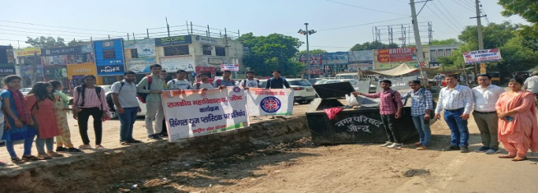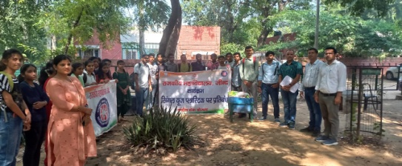
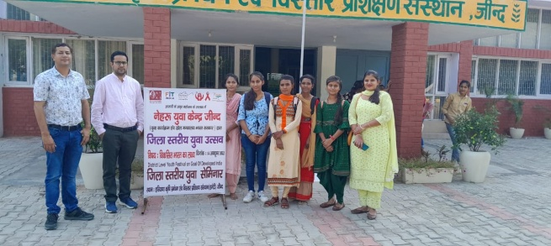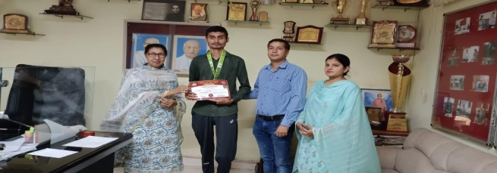
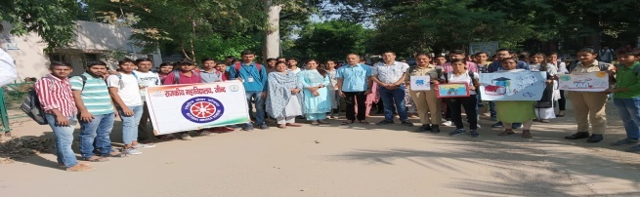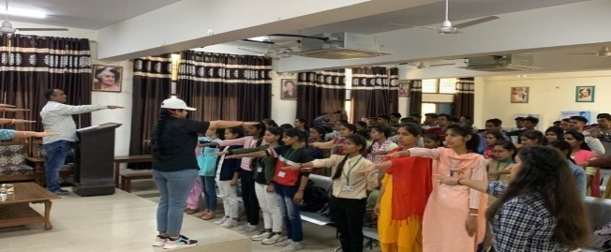

DEPARTMENT OF ECONOMICS
CONVENOR: SH. MANOJ KUMAR

- Organised a slogan and poster making competition on Eradiction of poverty for the students on 11th November 2022.
- Organised a seminar on issues in Indian Economy for students on 12th December 2022.
- Organised Quiz competition for students on 12th April 2023.

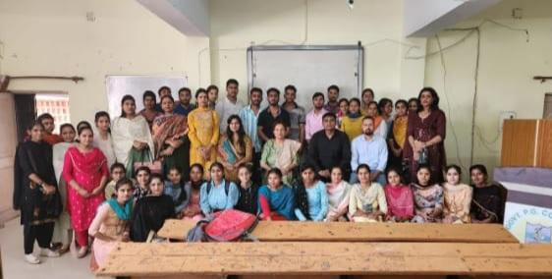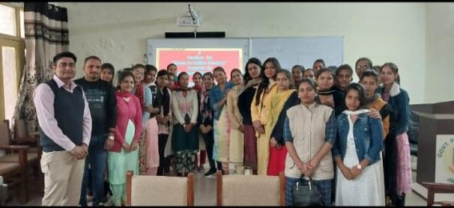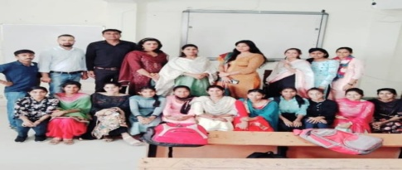
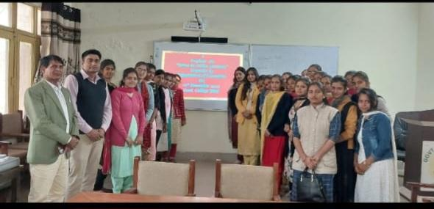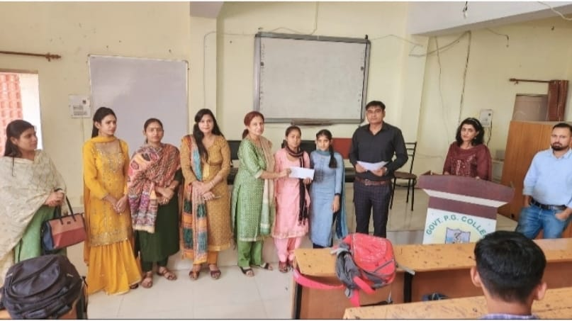

DEPARTMENT OF PHYSICS
- A speech competition was organised by th Department of Physics on 21/11/2022.
Dr. Balkrishna Kandpal was convener of this competition.
The judges were appointed, namely Mr. Ashish Kumar, Mr. Yashpal and Mrs. Rachna for this speech competition.
The topic for this competition was the Role of Artificial Intelligence.
The following students got first three positions
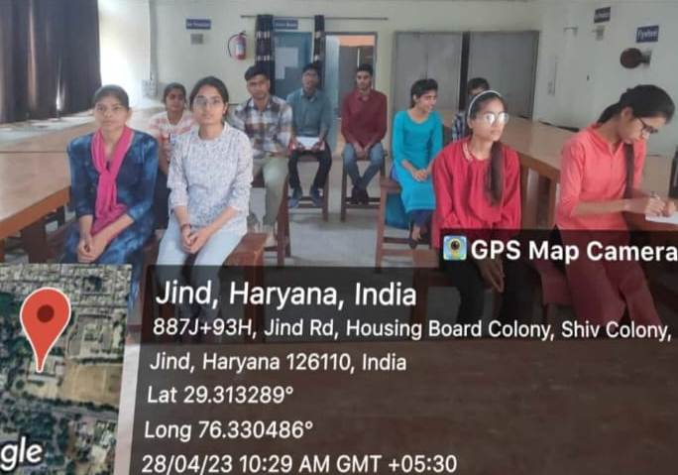
1. PRIYANSHU 1210681015002, B.Sc. 3rd Semester
2. SAURABH 1210681015152, B.Sc. 3rd Semester
3. SHUBHAM 1220681015111, B.Sc. 1st Semester

- A poster making competition was organised by the
Department of Physics on 10/04/2023. Mrs. Reena Rani
was convener of this competition. The judges were
appointed, namely Mrs. Rachna , Mrs. Shweta and Mrs.
Renu Jakhar for this poster making competition. The topic
for this competition was Science for people enabling
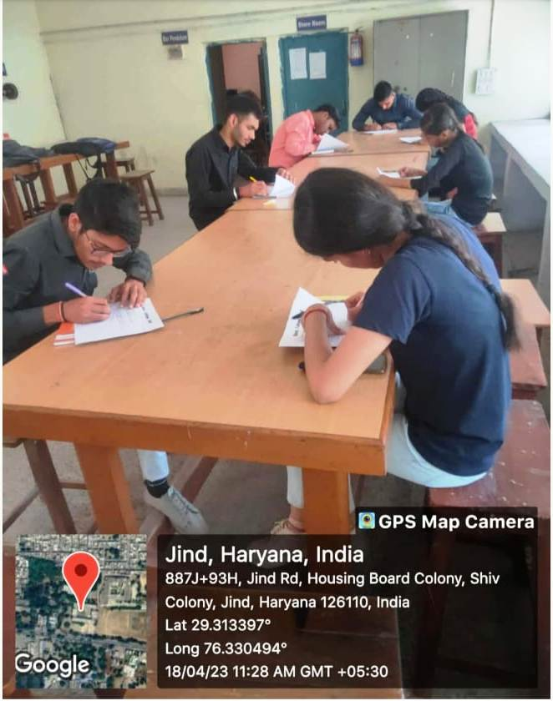
technology for sustainable development. The following
students got first three positions
1.Himanshu 1210681015012 B.Sc.3rd Semester
2.PRIYANSHU 1210681015002 B.Sc. 3rd Semester
3. Hitesh 1210681015168, B.Sc. 3rd semester

- A essay writing competition was organised by the
Department of Physics on 18/04/2023. Mrs. Renu Jakhar was convener of this competition. The judges were appointed, namely Dr. Balkrishna Kandpal, Mr. Narender kumar and Mr. Ashish for essay writing competition. The topic for this competition was Reinventing the future: Advancing community through science and technology and
innovation. The following students got first three positions

PRIYANSHU | 1210681015002 | B.Sc. 3rdSem
PRAGATI | 1210681015103 | B.Sc. 3rd Sem
HITESH | 1210681015168 | B.Sc. 3rd Sem

- A Physics Quiz competition was organised by the Department of Physics on 28/04/2023. Mrs. Rachna was convener of this competition. The quiz master, time keeper,& scorer were appointed, namely Mrs. Renu Jakhar, Mrs. Reena rani and Mrs. Shweta for Physics Quiz competition. Five teams participated in this competition .The following students got first three positions

MONIKA | 120068015134 | B.sc 3rd year
SONIA | 12006815049 | B.sc3rd year
RAHUL | 1220681015005 | B.sc1st year

- A essay writing competition was organised by the Department of Physics on 18/04/2023. Mrs. Renu Jakhar was convener of this competition. The judges were appointed, namely Dr. Balkrishna Kandpal, Mr. Narender kumar and Mr. Ashish for essay writing competition. The topic for this competition was Reinventing the future: Advancing community through science and technology and
innovation. The following students got first three positions
. PRIYANSHU | 1210681015002 | B.sc 3rd sem
. Pragati | 1210681015103 | B.sc 3rd sem
. Hitesh | 1210681015168 | B.sc 3rd sem

- A Physics Quiz competition was organised by the
Department of Physics on 28/04/2023. Mrs. Rachna was
convener of this competition. The quiz master, time keeper,
& scorer were appointed, namely Mrs. Renu Jakhar, Mrs.
Reena rani and Mrs. Shweta for Physics Quiz competition.
Five teams participated in this competition .The following
students got first three positions
Monika  Sonia | 120068015134  120068015049 | B.Sc. 3rd year  B.Sc. 3rd year
Rahul  Sukhbinder | 1220681015005  1220681015008 | B.Sc.1st year  B.Sc. 1st year
Nidhi  Deepti | 120068015034  120068105066 | B.Sc. 3rd year  B.Sc. 3rd year

YOUNG GEOGRAPHER CLUB
CONVENOR: SH. VIKRAM DANDA
l= 2022-23 esa Hkwxksy foHkkx ds ;qok Hkwxksy DyCk }kjk fuEufyf[kr xfrfof/k;ka vk;ksftr djokbZ xbZA
- fnukad 16.09.2022 dks Hkwxksy ;qok Dyc }kjk vkstksu fnol ds miy{; esa Slogan writing izfr;ksfxrk dk vk;kstu fd;k x;k ftldk fo’k; ^i`Foh ij thou j{kk djus okyk oSf”od lfg;ksx* Fkk rFkk blesa 24 fo|kfFkZ;ksa us Hkx fy;kA fnukad 29.09.2022 dks Hkwxksy foHkkx ds fo|kfFkZ;ksa ds }kjk Hkwxkssy ;qok Dyc ds inkf/kdkfj;ksa dk pquko fd;k x;kA ftlesa President fodkl] Co- President lfpu] Secretary lqfer, Organise Secretary eksfudk rFkk Joint Secretary jkgqy dks yksdra= fof/k ls pquk x;kA
- fnukad 04.10.2022 dks World Habitat Day ds volj ij Dr. Viren (Biotech-Dept.) }kjk Extension Lecture djok;k x;k ftlesa egkfo|ky; ds 95 fo|kfFkZ;ksa }kjk blesa Hkkx fy;k x;kA fnukad 05.12.2022 dks Soil Day ds volj ij Biotech foHkkx ds Dr. Poonam us O;k[;ku fn;k ftldk fo’k; Soil Conversation FkkA
- fnukad 14.12.2022 dks National Energy Conservation Day ds miy{; esa ;qok Hkwxksy }kjk okn& fookn izfr;ksfxrk djokbZ xbZ ftlesa 8 Team us Participate fd;k ftlesa izFke LFkku ;ksxs”k] f}rh; jkgqy] fodkl o r`rh; LFkku ij veu o uhrw jgsA fnukad 28.02.2023 dks Inter- Class Geography Quiz Competetion djok;k x;k ftles 23 fo|kfFkZ;ksa us Hkkx fy;kA
- fnukad 03.03.2023 dks World Wildlife Day ds miy{; ij MkW0 lat; dqekj GCW Jind ds }kjk Wildlife Converstion ij O;k[;ku }kjk egkfo|ky; ds 88 fo|kfFkZ;ksa dks lEcksf/kr fd;kA fnukad 22.03.2023 dks World Water Day ds volj ij Poster-Making Competition vk;ksftr fd;k x;k ftldk fo’k; Accelerating the change to solve the water and Sanitation Crisis FkkA blesa 17 fo|kfFkZ;ksa us Hkkx fy;kA fnukad 22.04.2023 dks Earth Day ds miy{; esa Hkk’k.k izfr;ksfxrk esa 16 fo|kfFkZ;ksa us Hkkx fy;k ftles izFke LFkky lfpu] f}rh; lk{kh o r`rh; LFkku fiza;dk us izkIr fd;kA
- l= 2022-23 esa Hkwxksy foHkkx ds fuEu fo|kfFkZ;ksa us fuEufyf[kr Hkwxksy iz”uksÙkjh esa Hkkx fy;kA
Sr. No. | Date | Institute | Students | Position
1 | 07.12.2022 | D.A.V Karnal | Vikash, Yogesh, Amanjeet | III
2 | 16.02.2023 | G.C.W Ratia | Vikash, Dev, Sahil | III
3 |  | G.C Sirsa | Vikash,Yogesh, Sahil | -
4 | 28.02.2023 | Inter-Class Quiz | - | -
5 | 01.03.2023 | G.C Hansi | Vikash, Amanjeet, Sahil | III
6 | 06.03.2023 | D.A.V Ambala City | Dev, Amanjeet, Aman | -
7 | 06.03.2023 | G.C Safidon | Vikash, Sahil, Tamana | 1st
8 | 27.03.2023 | G.C.W Rohtak | Vikash, Sahil, Tamana | 1st
9 | 21.04.2023 | R.K.S.D Kaithal | Vikash, Sahil, Aman | 2nd
10 | 29.04.2023 | G.C.W Tasham | Vikash, Sahil, Aman | -
11 | 30.04.2023 | National Level, Panchkula | Vikash, Sahil, Tamana | 2nd

- fnukad 6-7.11.2022 dks Hkwxksy foHkkx ds veu o jkgqy us District Level Sceince Exhibition esa izFke LFkku izkIr fd;k rFkk Aman dks Best Exhibitioner pquk x;kA
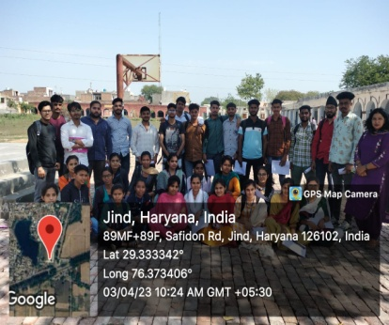 | 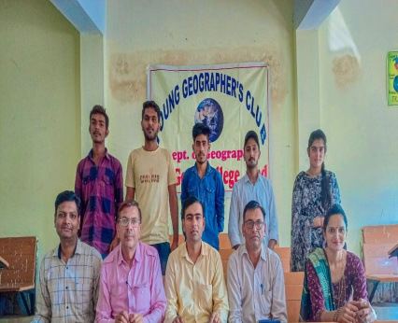 | 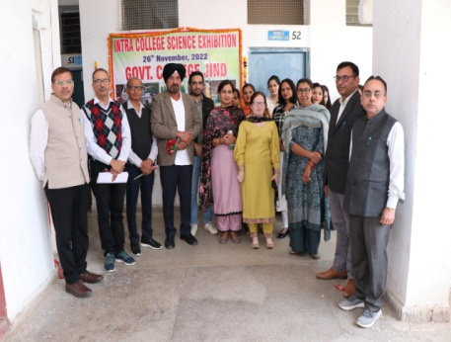

RED –RIBON CLUB
CONVENOR: SH. VIKRAM DANDA
- सत्र 2022-23 के तत्वाधान में रेड रिबन क्लब में 100 विद्यार्थियों का पंजीकरण किया गया।
- दिनांक 21.9.2022 को सिविल हॉस्पिटल जींद के द्वारा जिला स्तरीय प्रश्नोत्तरी प्रतियोगिता आयोजित करवाई गई जिसमें द्वितीय वर्ष के दो विद्यार्थियों सचिन और बिट्टू ने भाग लिया।
- 12 /12 /2022 को एड्स अवेयरनेस कैंपन के तहत Teacaids film दिखाई गई जिसमें 90 विद्यार्थियों ने भाग लिया ।
- दिनांक 16/ 12 /2022 को पोस्टर मेकिंग कंपटीशन का आयोजन किया गया जिसका विषय एचआईवी एड्स था जिसमें महाविद्यालय के 25 विद्यार्थियों ने भाग लिया बीए प्रथम वर्ष के नीतू ने प्रथम तथा द्वितीय वर्ष के योगेश ने द्वितीय स्थान प्राप्त किया।
- दिनांक 16 /1 / 2023 को AIDS Awareness Rally निकाली गई जिसमें रेड रिबन क्लब /NCC/NSS के 62 विद्यार्थियों ने अपनी सहभागिता दिखाई।
- दिनांक 17 /1 /2023 को AIDS Awareness Signature Campaign का आयोजन किया गया जिसमें महाविद्यालय के प्राध्यापकों, स्टाफ सदस्यों तथा विद्यार्थियों ने बढ़-चढ़कर भाग लिया।
- 7. दिनांक 3/3 /2023 को रेड रिबन क्लब के विभिन्न रिप्रेजेंटेटिव का चयन किया गया जिसमें विभिन्न पदाधिकारी में प्रेसिडेंट -गौरव ,को प्रेसिडेंट -नीत पीर हेड- सचिन, ट्रेजरार- अमन तथा सेक्रेटरी मुस्कान को बनाया गया।
- 8.दिनांक 28 /3/2023 को तपेदिक के लक्षण उपचार तथा रोकथाम के उपाय पर रेड रिबन क्लब द्वारा एक व्याख्यान आयोजित करवाया गया जिसमें सिविल हॉस्पिटल जीन्द से श्री संदीप गोयत डीपीसी द्वारा बच्चों को तपेदिक के बारे में जागरूक किया गया और इसमें महाविद्यालय के 111 विद्यार्थियों ने भाग लिया।
- 9.दिनांक 20 /4 /2023 को एचआईवी एड्स के लक्षण, कारण उपचार तथा बचाव पर आईसीटीसी काउंसलर श्री सत्येंद्र पाल सिविल हॉस्पिटल जींद द्वारा महाविद्यालय के 101 विद्यार्थियों को जागरूक किया गया । इसमें महाविद्यालय के 7 सदस्यों ने स्वेच्छा से अपने रैपिड एचआईवी टेस्ट करवाये।–

Woman Cell
CONVENOR: DR. JYOTI SHEORAN
Sr. No | Name of activity | Date of Program | Resource Person/Jury Member /Remarks
1. | Rangoli ,Painting &Slogan Writing  Competitions | 21st Sept.2022 | Dr. Bhawana, CRSU, Jind  Ms. Pallavi ,CRSU, Jind.
2. | Two Day Workshop on Art of Living  Theme Areas-Time Management, Confidence Building, Stress Management, Life& Happiness | 28th &29th Sept. 2022 | Mr. Naresh Jaglan, Social Activist, Jind
3. | Mehandi Competition | 12 th oct.2022
4. | 4 Day Workshop on Yoga | 14th Nov 2022 to 17th Nov 2022 | Mr. Birender, Yoga Expert
5. | Extension Lecture on Personality Development | 19th Nov.2022 | Prof. S.K Sinha,Dean Academic Affairs,CRSU,Jind
6. | Participation in Two Day Programme on the occasion of International Women’s day at CRSU, Jind . | 27th & 28th Feb 2023 | Third Position in Rangoli ,Ethenic Fashion Wear &mehandi Compt.’s,and Second position in Makeup Compt.
7. | Celebration of International Woman’s Day  Poetic Recitation Compt.  Speech Compt.  Extension Lectures(Theme Areas-Health& Hygine and Proper use of Vending machines | 13th march 2023 | Dr. Sunet Rani,Assistant Prof.,Dept. of Public Administration,GC,Alewa
8. | Participation of girl students in State Level Compt. on Legal Rights of Woman in India at IB College,Panipat. | 26th April 2023 | ---
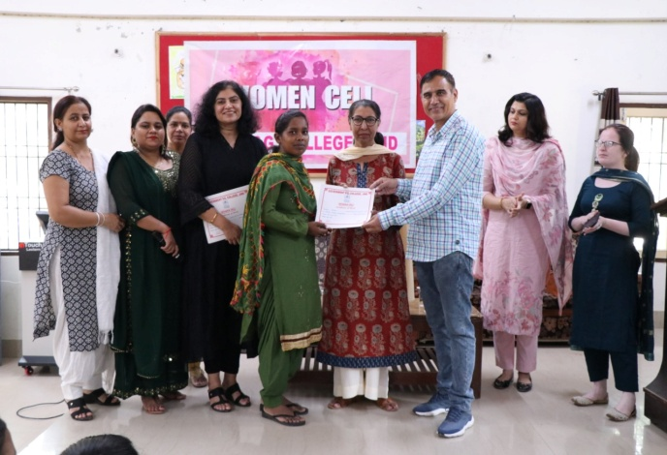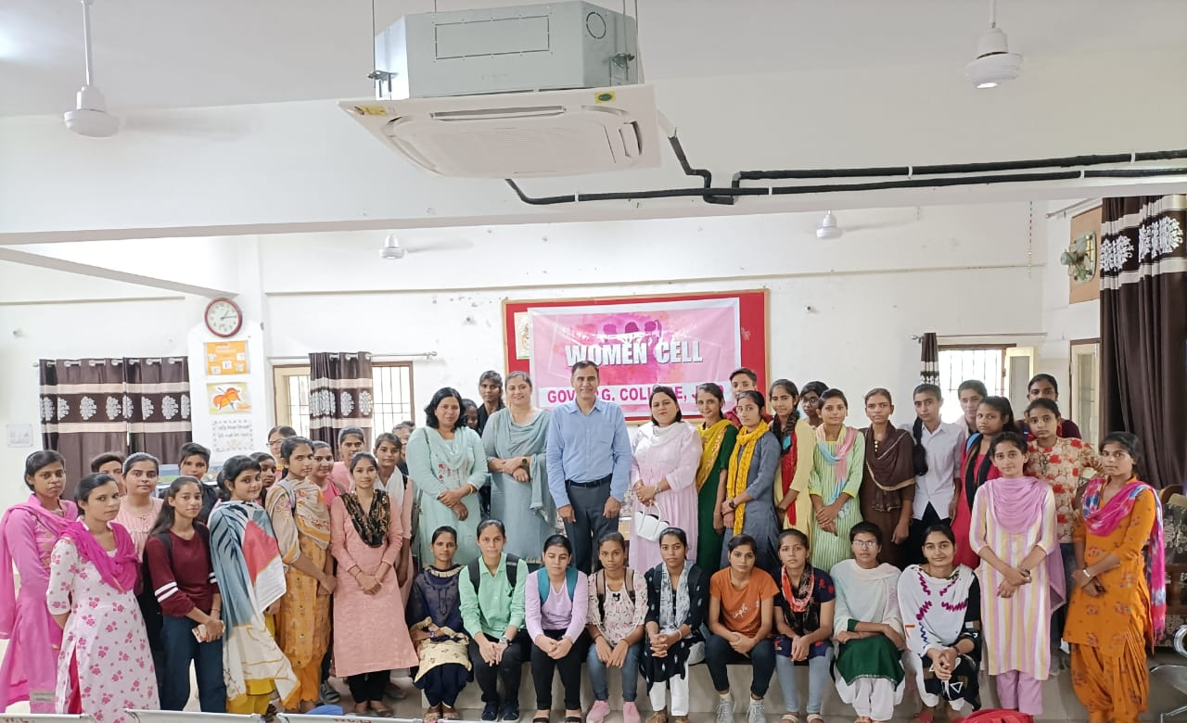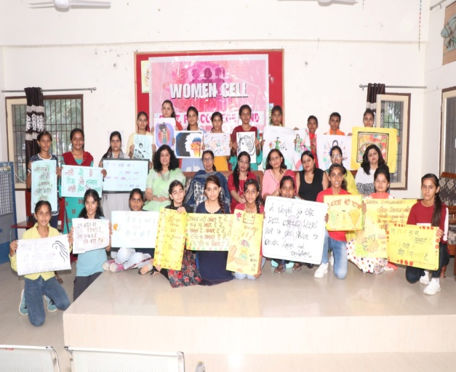

CENTERAL LIBRARY
CONVENOR: DR. JYOTI SHEORAN

Sr. No. | Name of Activity | Resource Person | Date of Program | Total no. of participants
1. | Orientation Program | Dr.Anil, Assistant Librarian, CRSU,Jind | 21/10/2022 | 71
2. | Books Exhibition in Chaudhary Ranbir Singh University | Dr. Jyoti Sheoran  Mrs. Ritu Rani  Mrs.Poonan visited Book Fair | 05/01/2023 | 03
3. | Book Fair | Book Fair | 05 &06/04/2023 | 500  Teachers&Students
4. | Lecture Series | Prof. Rishipal  Chairperson, Dept. of Psychology& Dean Pedagogy and Capacity Building ,Sh Vishwakarma Skill University,Palwal | 15/04/2023 | 75 students
5. | Book Donation | Received from Gayatri Parivar,Delhi | 15/04/2023 | Total books received 86(Eighty Six

Youth and Cultural Affairs Cell
CONVENOR: DR. JYOTI SHEORAN
- Talent Search Competition was organized by Govt. college, Jind on 07-10-2022 &10.10.2022 and Prize Winners were given away cash prizes @ 600,500 and 400 respectively for bagging First, Second and Third positions.
- .Cultural teams of Govt. College, Jind Participated in State level Sanzhi Utsav organized on 02/10/2022 to 04/10/2022by Saraswati kala Manch,Julana.
- Cultural teams of Govt. College, Jind participated in District level Youth festivalorganized by District Sports and Youth Program Officer at Motilal Nehru School,Jind.On 20/10/2022 and got first position in Guitar,second position in Kathak and third position in Speech.
- Team of 6 students of Govt. College, Jind participated in District Level Essay Writing, Declamation and Rangoli Making competition and got Essay writing-First& Third Positionin Essay writing,second position in Declamation Third Position inRangoli.
- GC, Jind teams participated in Zonal youth Festival Safidon Zone, Jind which was hosted by H.K.M.V Jind on 16&17/11/2022And got Overall Running Trophy ,First Position in Solo dance Male ,Solo dance Female ,Western Instrumental and 2nd position in Western Vocal Solo, Haryanvi Gazal, Mimicry and Skit Haryanvi.
- Govt. college, Jind teams participated in Inter Zonal Youth Festival organized at CRSU, Jind on 22 to 24/12/20221.-First Position in Solo dance Female, Western Instrumental, Debate, Skit,General Quiz and 2nd position in saang Haryanvi ,Western Vocal Solo and Installation.
- Govt. College, Jind students represented CRSU, Jind in Inter University North Zone Youth Festival at MM College, Mulana on.24-28/01/2023.
- Participation and presentation of events in Annual prize distribution programme at Govt. College, Jind. on05/12/2022
- A team of students participated in celebration of 13th National Voters Day organized by District Election Office, Jind. On25/01/2023 and got First, Second& Third Positions in Speech compt.& Poetry Compt.
- A team of students represented GC, Jind in celebration of India’s G-20 presidency programme at PIG GCW,Jind. On 01/03/2023.
- Govt. College, Jind Participated in Inter College State level cultural fest 2023 Rang-Tarang at Govt. College ,Julana on 28/03/2023 and got Overall Running trophy ,1st position in Haryanvi Geet ,Mimicry ,Declamation, Rangoli and 2nd position in Haryanvi ragni, Poster making ,Mono Acting , On The spot Painting andThird Position inPoetic Recitation.
- Cultural teams of Govt. College ,Jind participated in State level cultural Fest at Dayanand Mahila Mahavidyala ,Kurukshetra on 08/04/2023.
- Cultural teams of Govt. College, Jind participated in State level Cultural Festival at Indira Gandhi Mahila Mahavidyalaya , Kaithal on 25/03/2023.
- Cultural teams of Govt. College,Jind participated in District Level Youth Festival organized by District Youth Officer ,Nehru Yuva Kendra, Jind at PIG GCW, Jind on 04/05/2023 and gotFirst Position in Speech Compt.-5000 cash prize
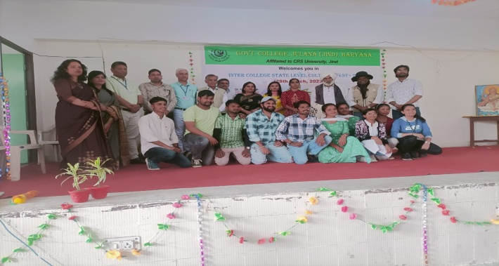
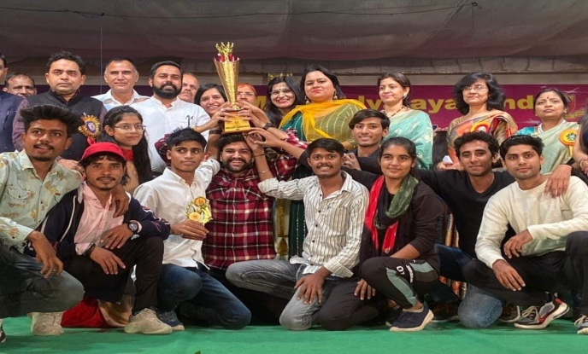
.
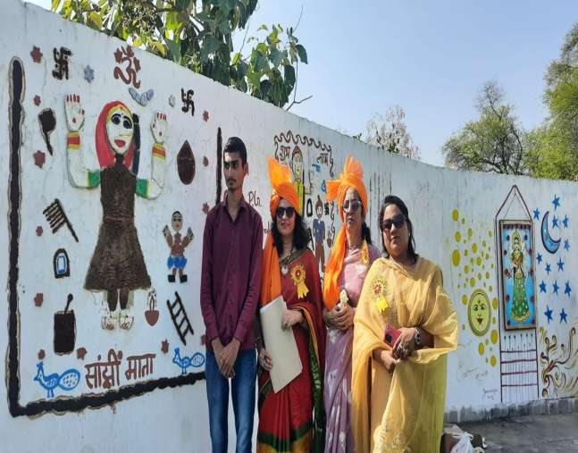
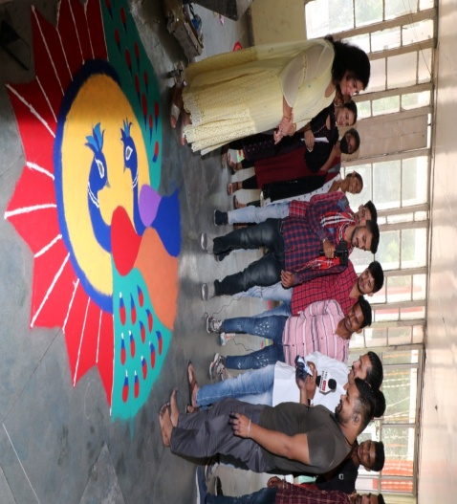
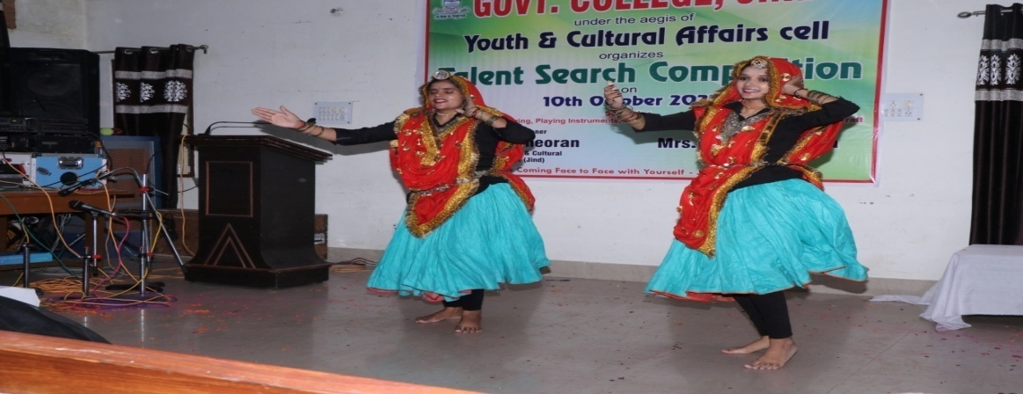
Department of Mathematics
HOD- DR. RAJ KAMAL
On, 03/04/2023, Intra-college poster making competition was organized by the Department of Mathematics of this college. The topic for the competition was mathematical concepts. Thirteen students of B.A./B.Sc (Mathematics) participated in this competition. Sh. Munish Kumar, Sh. Mukesh and Ms. Nisha Pruthi performed duties as judges of this competition.
Positions were as follows.
Ist- Priyanshu, B.Sc-2nd ( C), Roll no-1210681015002
IInd-Kirti, B.Sc-3rd ( C), Roll no-120068015037
IIIrd –Hitesh, B.Sc-2nd ( C), Roll no-1210681015168
Prize money of Rs-500, 300, 200 has been given to Ist, IInd, IIIrd position holder respectively.

Entrepreneurship Development
CONVENOR: SMT. YASWANTI
- Organized a workshop on 19th oct. 2022 the title of the workshop was “How to think about a Startup Idea and how to start Entrepreneurship Journey with Zero investment.
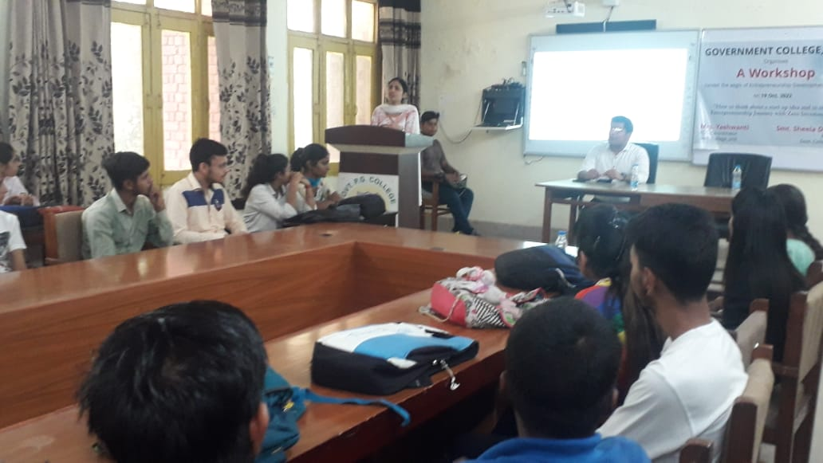
- Students participated and secured 2nd and 3rd position in District Level ‘Business Tiger Competition” on 28th Nov. 2022 organized by Jind Institute of Engineering and Technology. 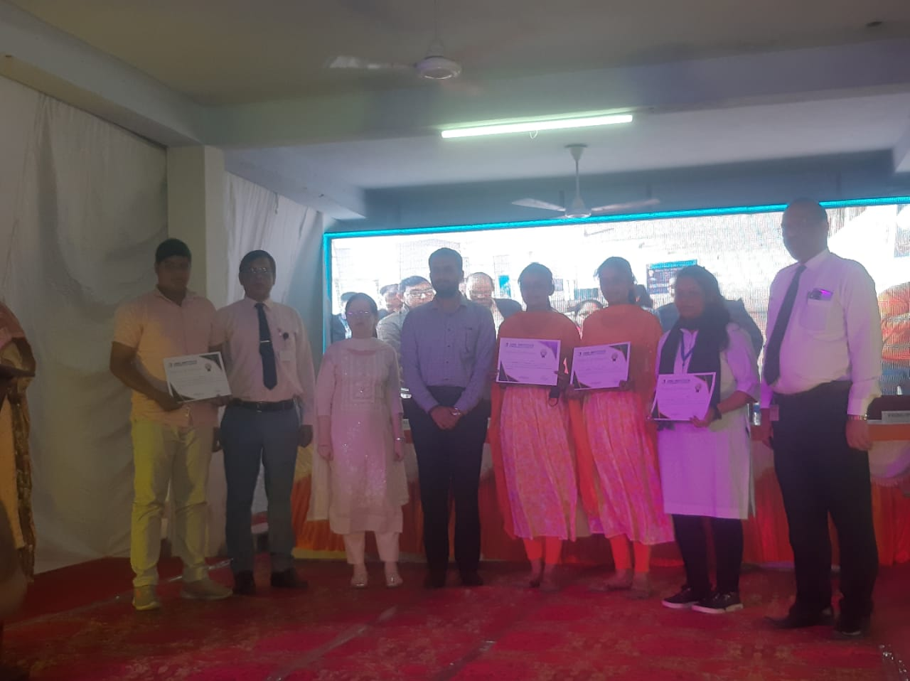
- On 29th Nov. 2022 an Industrial Visit was organized at Lakshya Milk Plant, V.P.O Kandela.
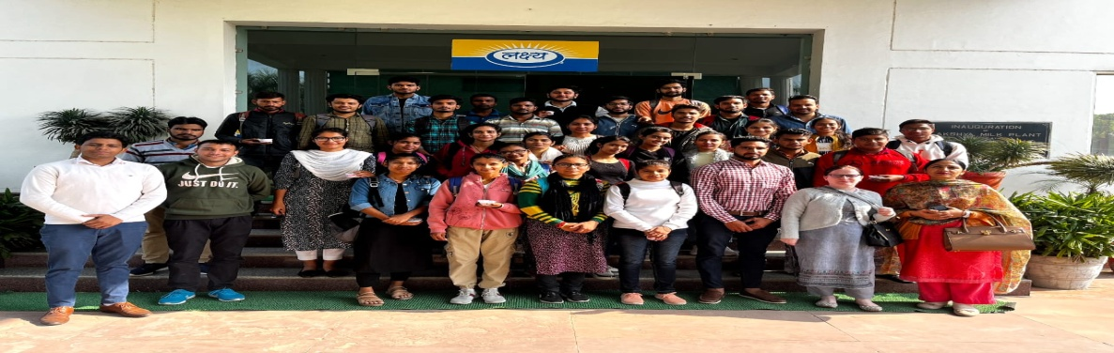

- An extension Lecture was organized on 16th Dec. 2022 on Interview skills, Resume Building and Entrepreneurship in collaboration with Commerce society.
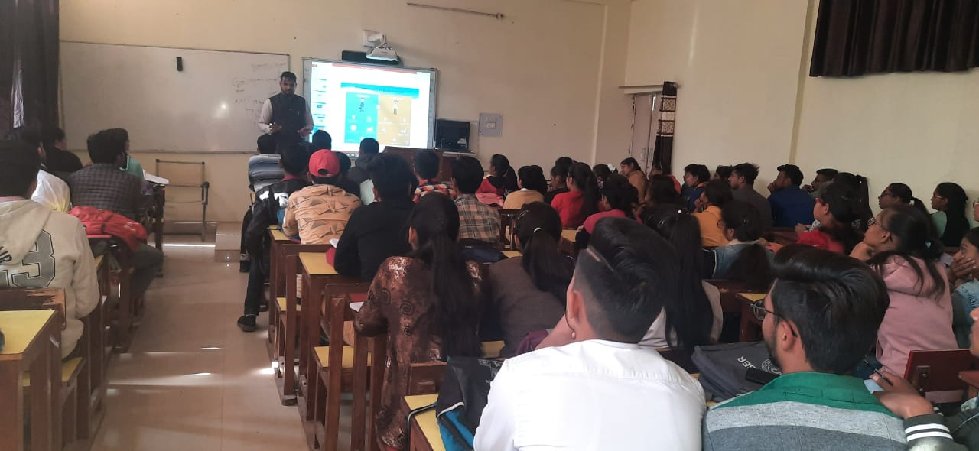

COMMERCE DEPARTMENT
ACTIVITY INCHARGE- SH. LABH SINGH
- A workshop was organized on “How to write Dissertation” for M.Com 3rd sem. students.
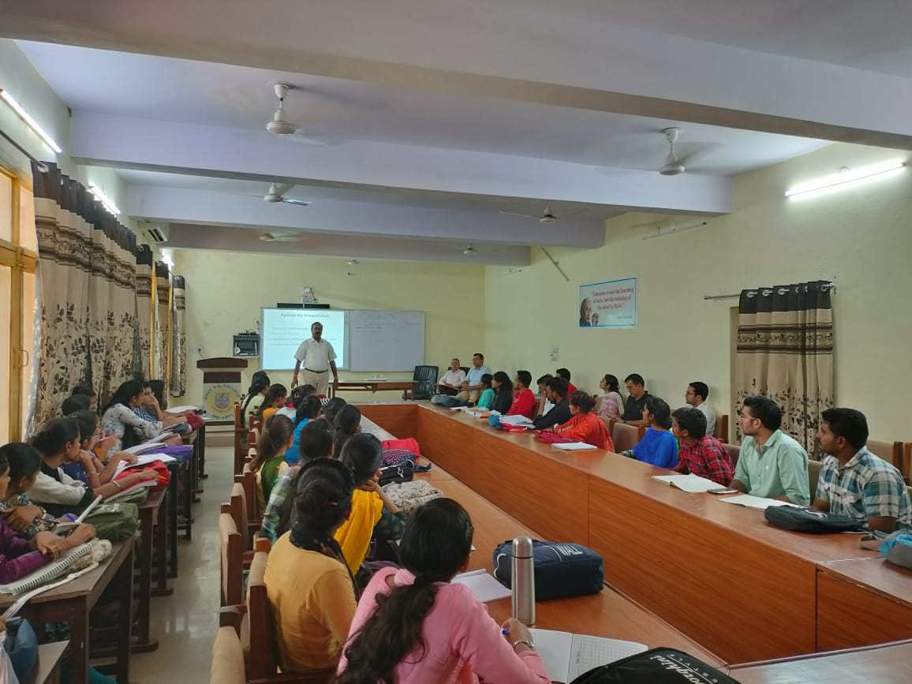
- Organized an extension Lecture on “Interview skills, Resume Building and Entrepreneurship” in collaboration with ED Club.
- A Commerce Quiz competition was organized on 24th April 2023.
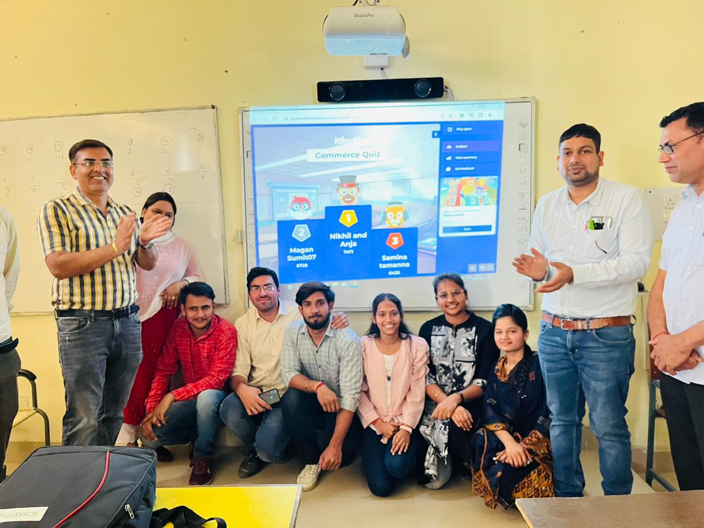

DEPARTMENT OF BOTANY AND BIOTECH
- Department of Botany and Biotech organised a group discussion for students of science stream on the theme 'Biodiversity ' on 28 Oct ,2022
- Department of Botany and Biotech in collaboration with Department of Chemistry organised a slogan writing competition on the topics Save the environment, Green Chemistry, Global warming on 18 March,2023 Department of Botany and Biotec collaboration with Department of Chemistry organised a seminar on the theme 'Environmental Science ' on 29 April

DEPARTMENT OF CHEMISTRY
- Department of Chemistry organised a group discussion for students of science stream on the theme 'Chemistry in daily life'on 28 Oct ,2022
- Department of Chemistry in collaboration with Department of Botany and Biotech organised a slogan writing competition on the topics Save the environment, Green Chemistry, Global warming on 18 March,2023
Department of Chemistry in collaboration with Department of Botany and Biotech organised a seminar on the theme 'Environmental Science ' on 29 April
DEPARTMENT OF ZOOLOGY
1. Department of zoology organised a essay writing competition for students of science stream on 01August, 2022
2. Department of zoology organised a slogan writing competition on 15 March, 2023
3. Department of zoology organised a Herbal park visit for Science students on 17 April, 2023.
4. Department of zoology organized a quiz competition on 25 April, 2023
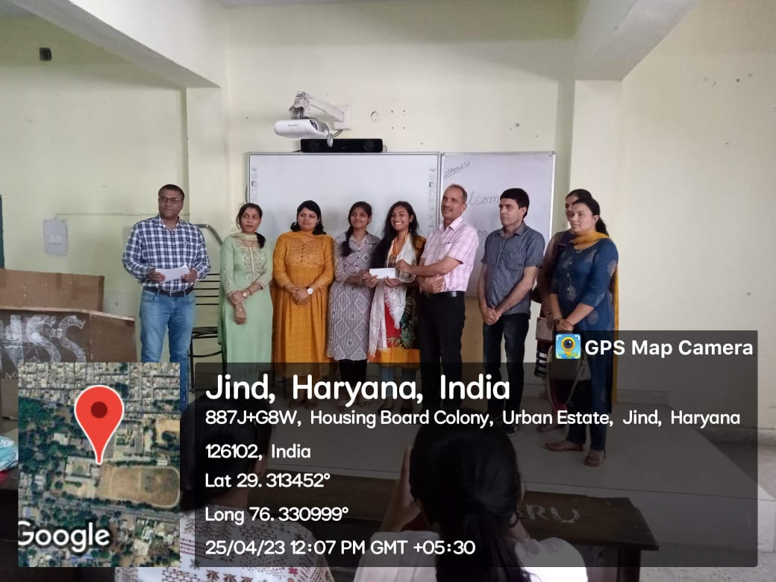 | 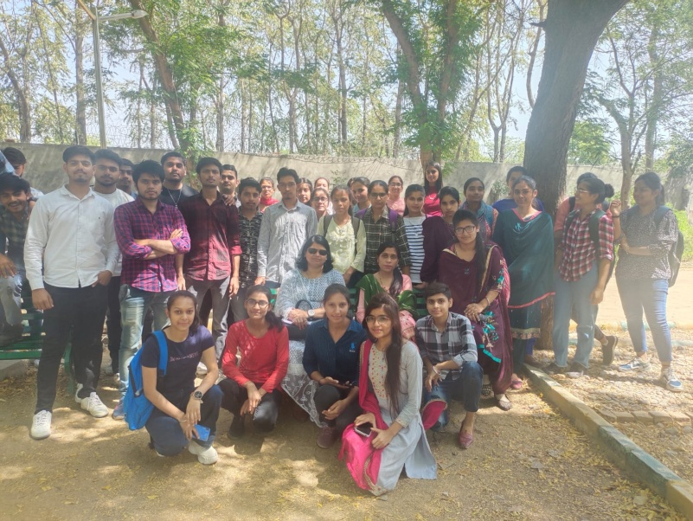

Guidance Bureau and Placement cell
1. Organized seminar on HOW TO PREPARE FOR CIVIL SERVICES in association with WILZ Academy dated 20.10.2022 at Girls common room @12 pm onwards.
138 students attended and get benefited.
2. Organised two extension lectures on CAREER ORIENTED EFFECTIVE APPROACH FOR CAPACITY BUILDING IN GIS and REMOTE SENSING TECHNOLOGIES IN SUSTAINABLE DEVELOPMENT for the students of Geography dated 19.11.2022 at room-68 @ 12:30 pm to 2:30 Pm.
92 students attended the lectures.
- Organized campus Placement camp in association with INDUS SALVAGE PVT. LTD. GURUGRAM dated 27.4.2023 at Vinay memorial Hall @ 09 Am onwards. 16 students got offer letter with an annual package of INR 2.40 lakh.
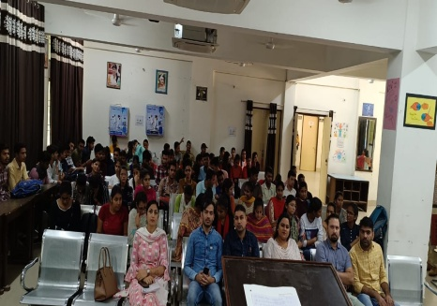
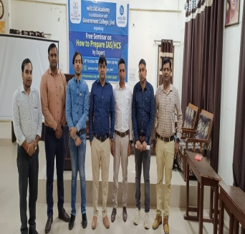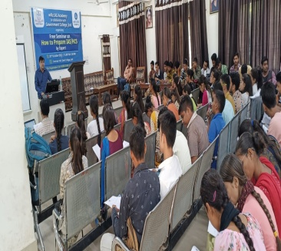

LITERARY SOCIETY
CONVENOR: DR. VISHAL REDHU

1. Extension lecture was organized on the topic: Literary theories by Dr. Vikas Lather,Associate Professor of English Govt. college for women Safidon on 14-11-2022
2. Mushiara was organized on 05-04-2023
3 Paper Reading Competition was organised on dated 15-04-2023
- Poetry Reading competition was organized on 06-05-2023

NCC ACTIVITIES

CONVENOR: ANO LT. PANKAJ BATRA

The NCC Unit of Govt. College Jind is functioning under the 15 Haryana Battalion NCC, Jind which consists of the total enrolled strength of 160 Senior Division (SD-Boy) cadets and 106 Senior Wing (SW-Girl) cadets. The NCC Company of the college comes under the Ambala Group of Punjab Haryana Himchal Pardesh & Chandigarh (PHHP&C) NCC Directorate. Brigadier AS Vaid as our Group Commander and Colonel Anurag Mehra as the Commanding Officer, Lt. Pankaj Batra as the Associate NCC Officer (ANO) . NCC in the college plays a credible role in shaping the character of students by instilling the values of patriotism, service, discipline and hard work. Training in NCC insists qualities like nationalism, patriotism, discipline, teamspirit, leadership, self-confidence and promote overall personality development. NCC gives a tremendous opportunity to one and all betterment, irrespective of caste, creed, religion and economic status.

Activities Overview
The NCC Unit of Govt. College Jind is engaged in three types of activities :
- Social Service & Community Development Activities (SSCD)
- Camp and Training Activities
- Celebration of Important National and International Days

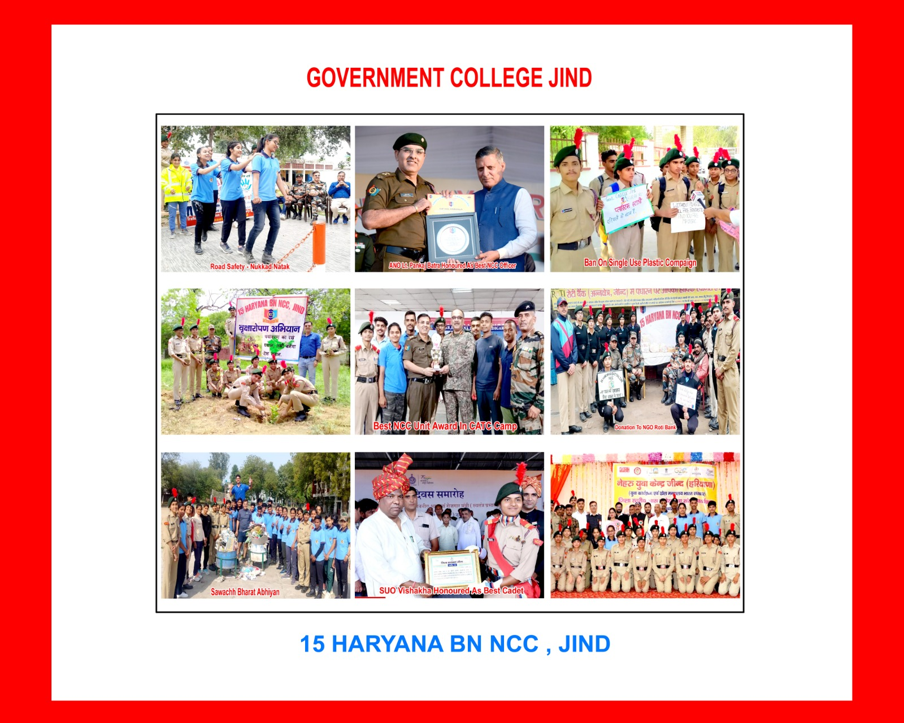

Social Service & Community Development (SSCD)
The NCC cadets of the institution actively participated in several Social Service & Community Development Programmes/activities during the academic year 2022-23:
- Mera Podha Meri Jimmedari Abhiyan
- Har Ghar Tiranga compaign
- Tiranga Cycle Rally
- Ban on Single Use Plastic Compaign
- Tiranga Parbhat Feri
- Blood Donation Camp
- Punit Sagar Abhiyan (cleanliness of nearby water bodies)
- Swacchta Abhiyan
- Care of Old Aged People & Patients living in rural areas
- Donation to NGOs Roti Bank, Help-A–Mission, Jan Sewa Sansthan
All these community outreach activities were performed in collaboration with District Administration Authorities, District Level organizations, Non-Govt. Organizations (NGOs) and General Public. The basic purpose behind these activities is to to create awareness, inculcate patriotic feeling and sense of selfless service among the students.

CELEBRATION OF NATIONAL AND INTERNATIONAL DAYS

During the academic year 2022-23, the following days were celebrated by the NCC Unit of the college :
- Independence Day (15.08.2022)
- World Hospice & Palliative Care Day (08.10.2022)
- Sardar Vallabh Bhai Patel Jayanti (31.10.2022)
- NCC Day (27.11.2022)
- New Year (01.01.2023)
- Republic Day (26.01.2023)
- World Cycle Day (03.06.2023)
- World Environment Day (05.06.2023)
- International Yoga Day (21.06.2023)

NCC CAMP & TRAINING ACTIVITIES
During the academic session 2022-23, the cadets of NCC Unit showed remarkable performance in the State & National Level camps of NCC. The List of Participated Cadets in various camps is as under:

Duration of Camp | Name of Camp | Type of Camp | Name of Cadet Participated | Cadet No.
6/7/22 to 15/7/22 | TSC/CATC | State Level | Vishakha | 238977
6/7/22 to 15/7/22 | TSC/CATC | State Level | Anjali | 238979
20/8/22 to 27/8/22 | Basic Leadership Camp (BLC) | State Level | Sahil | 239124
20/8/22 to 27/8/22 | Basic Leadership Camp (BLC) | State Level | Shubham | 239150
20/8/22 to 27/8/22 | Basic Leadership Camp (BLC) | State Level | Anuj | 239109
20/8/22 to 27/8/22 | Basic Leadership Camp (BLC) | State Level | Deepak | 239102
1/9/22 to 15/9/22 | Army Attachment Camp (AAC) | National Level | Yogesh | 239092
1/9/22 to 15/9/22 | Army Attachment Camp (AAC) | National Level | Jaideep | 239086
1/9/22 to 15/9/22 | Army Attachment Camp (AAC) | National Level | Ankit | 239076
1/9/22 to 15/9/22 | Army Attachment Camp (AAC) | National Level | Sahil | 239156
1/9/22 to 15/9/22 | Army Attachment Camp (AAC) | National Level | Ankush | 239033
7/9/22 to 18/9/22 | Advance Leadership Camp (ALC) | National Level | Sahil | 239124
7/9/22 to 18/9/22 | Advance Leadership Camp (ALC) | National Level | Shubham | 239150
7/9/22 to 18/9/22 | Advance Leadership Camp (ALC) | National Level | Deepak | 239102
7/9/22 to 18/9/22 | Advance Leadership Camp (ALC) | National Level | Sonu | 239111
10/10/22 to 19/10/22 | Ek Bharat Shresht Bharat Camp (EBSB) | National  Level | Amandeep | 239155
11/10/22 to 18/10/22 | DCAT – I | State Level | Lucky
11/10/22 to 18/10/22 | DCAT – I | State Level | Yogesh | 239092
11/10/22 to 18/10/22 | DCAT – I | State Level | Amandeep
11/10/22 to 18/10/22 | DCAT – II | State Level | Sahil
13/11/22 to 20/11/22 | DCAT – II | State Level | Yogesh | 239092
13/11/22 to 20/11/22 | DCAT – II | State Level | Vishakha | 238977
22/11/22 to 29/11/22 | IGC | State Level | Yogesh | 239092
22/11/22 to 29/11/22 | IGC | State Level | Vishakha | 238977
27/11/22 | 75th NCC DAY | State Level | Anu | 238931
27/11/22 | 75th NCC DAY | State Level | Manisha | 238904
27/11/22 | 75th NCC DAY | State Level | Yogesh (Guard of Honour) | 239092
30/11/22 to 07/12/2022 | Pre RDC - I | State Level | Vishakha | 238977
9/3/23 to 19/3/23 | Army Attachment Camp (AAC) | National Level | Priyanka | 238906
9/3/23 to 19/3/23 | Army Attachment Camp (AAC) | National Level | Sarita | 238909
9/3/23 to 19/3/23 | Army Attachment Camp (AAC) | National Level | Neetu | 238910
9/3/23 to 19/3/23 | Army Attachment Camp (AAC) | National Level | Nikita | 238921
9/3/23 to 19/3/23 | Army Attachment Camp (AAC) | National Level | Anu | 238931
9/3/23 to 19/3/23 | Army Attachment Camp (AAC) | National Level | Himanshi Khasa | 238986
9/3/23 to 19/3/23 | Army Attachment Camp (AAC) | National Level | Ankita | 238989
9/3/23 to 19/3/23 | Army Attachment Camp (AAC) | National Level | Reeti | 238993
9/3/23 to  19/3/23 | Army Attachment Camp (AAC) | National Level | Nisha | 238995
9/3/23 to 19/3/23 | Army Attachment Camp (AAC) | National Level | Preeti | 238986
24/4/23 to 5/5/23 | BLC | State Level | Vinay | 239037
24/4/23 to 5/5/23 | BLC | State Level | Shubham | 239150
15/6/23 to 26/6/23 | EBSB – II | National Level | Sahil | 239156
15/06/23 to 26/06/23 | EBSB – II | National Level | Rakesh Kumar | 239034
15/06/23 to 24/6/23 | CATC | State Level | SUO Anu | 238931

Achievements
- SUO Vishakha honored by the District Administration as Best NCC Cadet
- NCC Cadet Abhishek Won Silver Medal In Yoga in 36th National Games
- First Position on Independence Day Parade
- Second Position on Republic Day Parade
- ANO Lt. Pankaj Batra honored by the District Administration on 76th Independence Day
- ANO Lt. Pankaj Batra honored by PHHP&C Directorate, Chandigarh on 75th NCC Day
SPORTS
CONVENOR: SH. RANDHIR SINGH

Ekgkfo|ky; ds Nk=&Nk=kvksa us l= 2022&23 esa fo”ofo|ky;] var% fo”ofo|ky;] jkT; ,oa jk’Vª dh [ksy&dwn izfr;ksfxrk esa Hkkx ysdj egkfo|ky;] fo”ofo|ky; vkSj gfj;k.kk izns”k dk uke jks”ku fd;kA bl o’kZ egkfo|ky; dh rSjkdh] okWVj iksyks] ØkWl&daVªh] fØdsV] ckWfDlax] jk’Vªh; dcM~Mh] QqVckWy] [kks&[kks] dq”rh] ;ksx o ,FkySfVDl dh Vheksa us fofHkUu izfr;ksfxrkvksa esa c<+p<+dj Hkkx fy;kA bl l= dh [ksy&dwn xfrfof/k;ksa ,oa eq[; miyfC/k;ksa dk laf{kIr fooj.k bl izdkj gS&

Name | Class | Game | Position
ATUL | B.A.I | Cross Country | 3rd
CHINKU | B.A. III | Cross Country | 3rd
RAHUL KHATKAR | B.SC II | Cross Country | 3rd
GOURAV | B.COM II | Cross Country | 3rd
AMANDEEP | B.A.I | Cross Country | 3rd

MAMTA | B.A.II | KHO KHO | 3rd
MADHU | B.A.III | KHO KHO | 3rd
SUMAN | B.A.I | KHO KHO | 3rd
KHUSHBU | B.A.III | KHO KHO | 3rd
GEETA | B.A.III | KHO KHO | 3rd
SUMAN | B.A.III | KHO KHO | 3rd
PRIYA | B.A.III | KHO KHO | 3rd
MANISHA | B.A.I | KHO KHO | 3rd
KIRAN | B.A.I | KHO KHO | 3rd
POOJA | B.A.I | KHO KHO | 3rd
ANTUL | B.A.III | KHO KHO | 3rd
RITU | B.A.III | KHO KHO | 3rd

SEEMA | B.A. III | Athletics | gold medal in 200 & 400meter race
NISHU | B.A. I |  | silver medaal in 1500,800
ROHIT | B.A. II |  | silver medaal in 400,200
AMANDEEP | B.A.I |  | gold in 400 meter hurdle
AMAN | B.A.II |  | bronze in high jump
RAHUL KHATKAR | B.SC II |  | bronze in 400 meter hurdle
MANJEET SINGH | B.A I | Kabaddi |  | 1st
ANIL | B.A.II | Kabaddi |  | 1st
AJAY | BSC I | Kabaddi |  | 1st
MANOJ | B.A. II | Kabaddi |  | 1st
ATUL DUTT | BA I I | Kabaddi |  | 1st
AADITYA | MA I | Kabaddi |  | 1st
SACHIN | B.A II | Kabaddi |  | 1st
ANKIT | BA I | Kabaddi |  | 1st
DEEPANSHU SHARMA | BSC I | Kabaddi |  | 1st
AMIT REDHU | B.A.I | Kabaddi |  | 1st

AMAN | B.A II | Basketball | 1st
VIKASH SHARMA | B.A II | Basketball | 1st
VINAY | BA I | Basketball | 1st
PARSHANT KUMAR | B.A. III | Basketball | 1st
SAWAN | B.A. III | Basketball | 1st
ASHISH | B.A II | Basketball | 1st
AMAN | B.A II | Basketball | 1st
AADITYA | MA I | Basketball | 1st
Vishal | B.A II | Basketball | 1st
Pawan | B.A. III | Basketball | 1st

AMAN | B.A I | Handball(Men) | 1st
SAHIL | B.A II | Handball(Men) | 1st
SAHIL | B.A II | Handball(Men) | 1st
MANISH | B.A.III | Handball(Men) | 1st
SHUBHAM | B.Com. I | Handball(Men) | 1st
ANKUSH MALIK | B.A.I | Handball(Men) | 1st
NAVEEV | B.Com. II | Handball(Men) | 1st
Ravi | B.A.I | Handball(Men) | 1st
Pawan | B.A.III | Handball(Men) | 1st
USHA | B.COM III | Handball(Women) | 3rd
GARIMA | B.A.I | Handball(Women) | 3rd
ANU | B.Sc II | Handball(Women) | 3rd
KIRAN | B.A.I | Handball(Women) | 3rd
NISHU | B.A.I | Handball(Women) | 3rd
NEHA | B.A II | Handball(Women) | 3rd
SAKSHI | B.A.I | Handball(Women) | 3rd
NEERAJ | B.A.III | Handball(Women) | 3rd
CHARV | B.A.I | Handball(Women) | 3rd
BINDU | B.A.I | Handball(Women) | 3rd

VISAL | B.SC.II | Kabaddi(Circle Style) | 3rd
AMAN KUMAR | B.A.II | Kabaddi(Circle Style) | 3rd
ASHISH | B.A.I | Kabaddi(Circle Style) | 3rd
ANKIT | M.A.I | Kabaddi(Circle Style) | 3rd
VIKRAM | B.SC.III | Kabaddi(Circle Style) | 3rd
KAMAL | B.A.III | Kabaddi(Circle Style) | 3rd
PARVEEN | B.A.II | Kabaddi(Circle Style) | 3rd
MONU | B.A.III | Kabaddi(Circle Style) | 3rd
MOHIT | B.A.III | Kabaddi(Circle Style) | 3rd
SUNIL | B.COM.I | Kabaddi(Circle Style) | 3rd
JITENDER | B.A.I | Kabaddi(Circle Style) | 3rd
ASHISH | B.A. II | Kabaddi(Circle Style) | 3rd
ASHOK | B.COM II | Kabaddi(Circle Style) | 3rd
SHUBHAM |  | Kabaddi(Circle Style) | 3rd

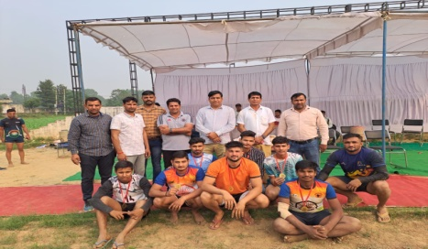 | 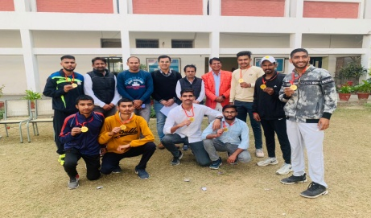
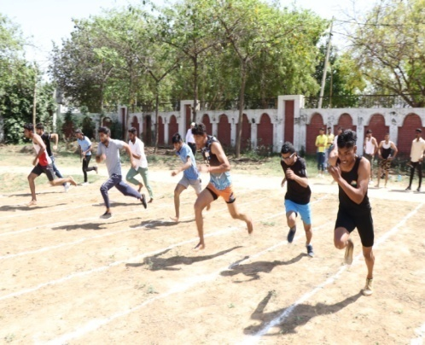 | 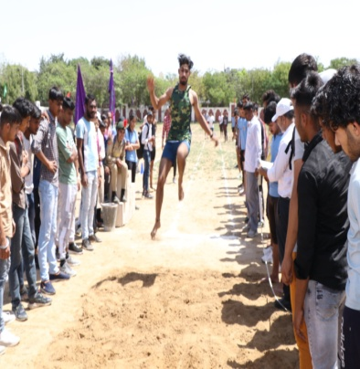
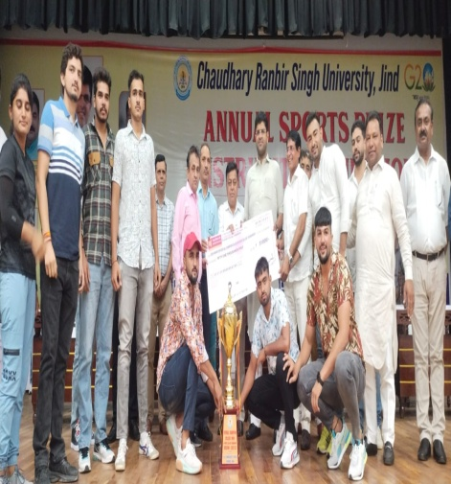 | 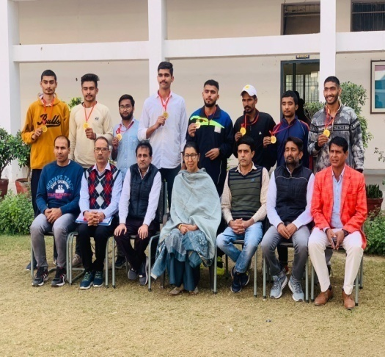

जनसंचार विभाग
कार्यक्रम रिपोर्ट -

- जनसंचार संबंधी गतिविधियों के प्रसार के लिए ‘मीडिया क्लब’ का गठन दिनांक 27 फरवरी 2023 को किया गया।
- जनसंचार विभाग में डिजिटल मीडिया में रोजगार की संभावनाएं विषय पर एक वार्ता कार्यक्रम का आयोजन दिनांक 22 अप्रैल 2023 को किया गया।
- जनसंचार विभाग के छात्रों ने दिनांक 28 अप्रैल 2023 को जींद एफएम ट्रांसमीटर केंद्र का भ्रमण किया।
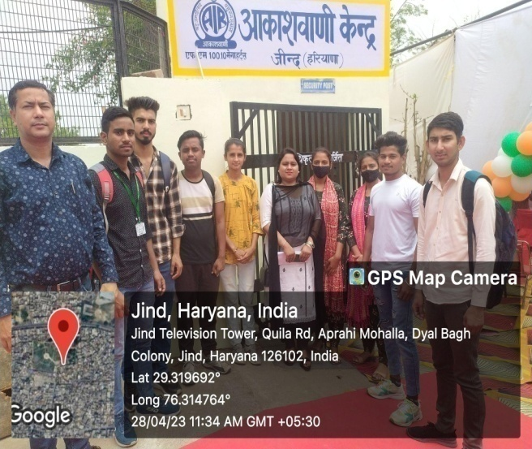 | 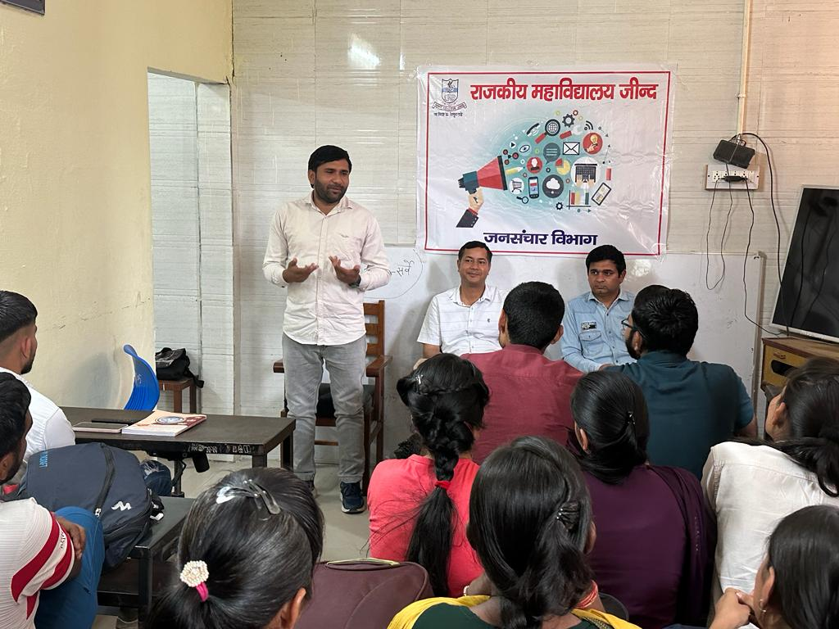

Computer Science Department

- Computer Science Department have Five Labs where students perform their practicals. One Lab is for Basic Computer Awareness.
- Students of BCA 3rd Year developed Websites in Project Development under the guidance of staff Members of Computer Science Department.
- Computer Science Department organized College Level Science Exhibition in 2022-23. Students of BCA 3rd Year (Raju and Vinay) got 1st Position in Science Exhibition and selected for Inter District Science Exhibition.
- The Student of PGDCA (Labh Singh) qualified UGC-NET Exam in 2022-23.
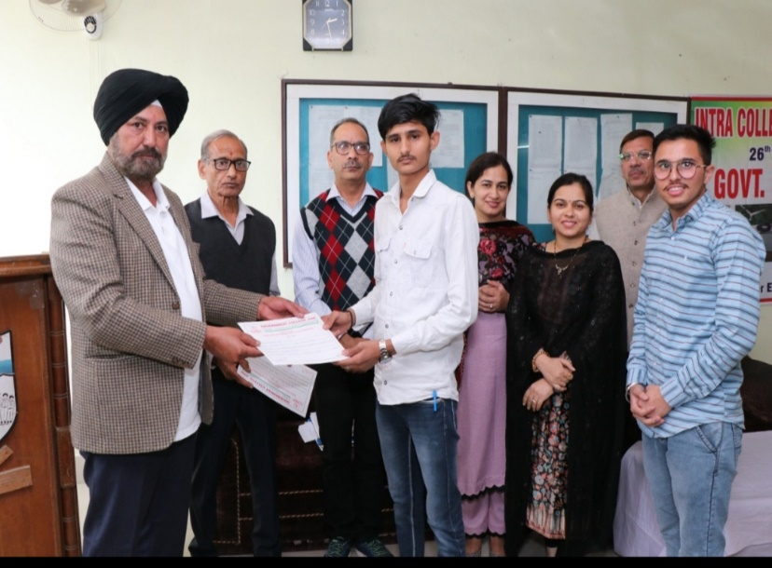 | 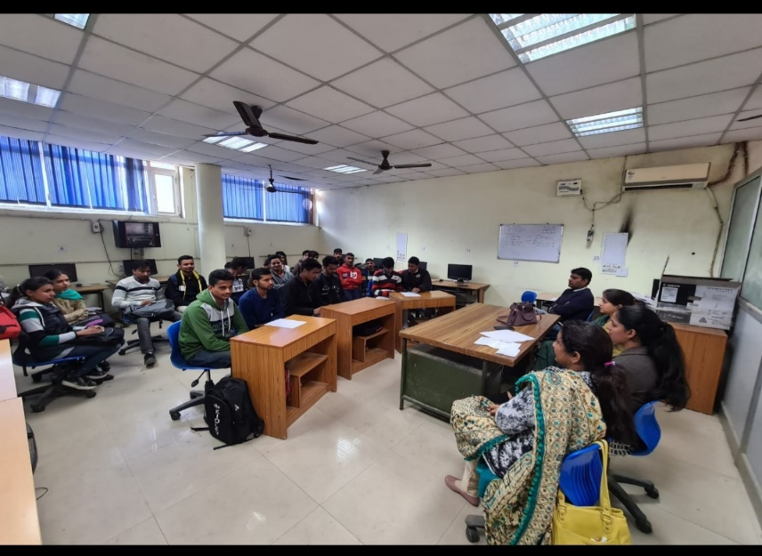

मनोविज्ञान विभाग
दिनांक 29.09.2022 को मनोविज्ञान विभाग द्वारा Mental Disorders विषय के तहत Group Discussion का आयोजन किया गया।
• दिनांक 26/11/2022 को विHkkx द्वारा महाविद्यालय में आयोजित विज्ञान प्रदर्शनी में हिस्सा लिया गया।
दिनांक 6-7 दिसम्बर 2022 को विभाग की टीम ने जिला स्तरीय विज्ञान प्रदर्शनी में जो कि राजकीय महाविद्यालय सफीदों में अयोftr की गई थी, izFke स्थान प्राप्त किया।
• दिनांक 21-22 फरवरी 2023 को विभाग की टीम ने राज्य स्तरीय विज्ञान प्रदर्शनी जो कि पंडित चिरंजी लाल शर्मा राजकीय महाविद्यालय करनाल में आयोजित हुई थी, हिस्सा लियाA
दिनांक 21 मार्च 2023 को विभाग द्वारा 'PSCHOLACIAL TOOLS विषय पर एक दिवसीय कार्यशाला का आयोजन किया गया।
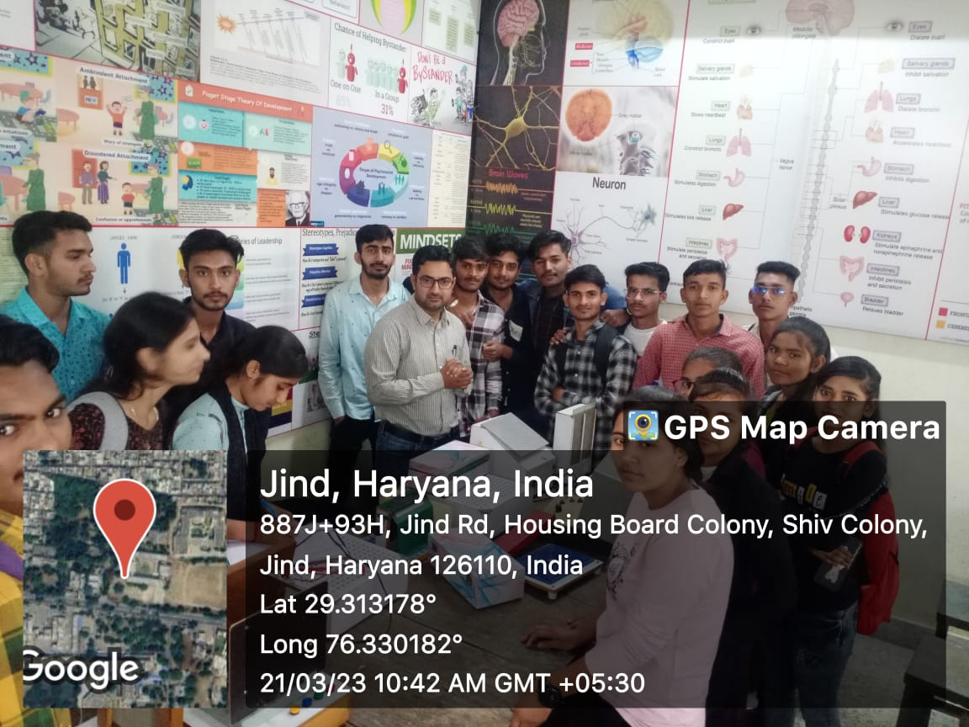

DEPARTMENT OF HINDI
दिनांक 25 /11/ 2022 को हिंदी विभाग द्वारा काव्य-पाठ प्रतियोगिता (महाविद्यालय स्तर) का आयोजन किया गया। इस प्रतियोगिता में दर्जनों प्रतिभागियों ने हिस्सा लिया। काव्य-पाठ का विषय,प्रतुतीकरण ,लय,भाषा की गरिमा की दृष्टि, से नीर-क्षीर विवेकी निर्णायक मंडल द्वारा निर्णय किया गया। नारी शिक्षा, स्त्री-पुरुष संबंध, भ्रष्टाचार, आम आदमी के जीवन पर प्रकाश डालने वाली सांस्कृतिक रचनाएं (कविताएं) विद्यार्थियों द्वारा प्रस्तुत की गई। गर्ल कॉमन रूम में आयोजित इस काव्य पाठ प्रतियोगिता के परिणाम इस प्रकार रहे:- प्रथम स्थान:- मनजीत बी ए प्रथम वर्ष
द्वितीय स्थान :-संयुक्त रूप से
रमन एम ए हिंदी द्वितीय वर्ष व अमन इंग्लिश ऑनर्स
तृतीय स्थान :-संयुक्त रूप से
राहुल बी ए प्रथम व सचिन बी ए तृतीय वर्ष निर्णायक मंडल डॉ सुनीता खर्ब व श्री हरज्ञान ।

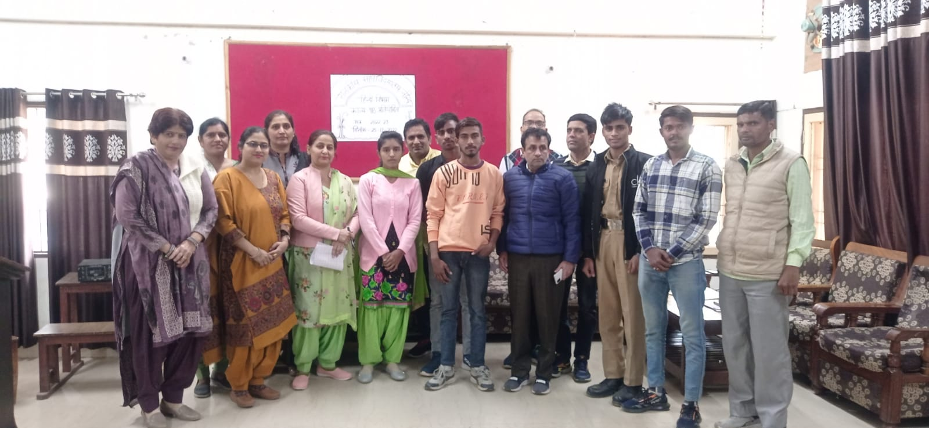
DEPARTMENT OF ENGLISH
- An extension lecture on the topic literary Theories was delivered by Dr. vikas lather on 14.11.22 for the students of PG classes or Hon. classes of Dept of English.
- 2.An inter college quiz competition under the aeges of Dept. of English was organised on 22.11.22 in which 8 teams from various colleges of Haryana participated the team of GC JIND bagged 1st position .
- 3.On 23.11.22 Dept of English Felicitated students who cleared their UGC /JRF exam during the last session.

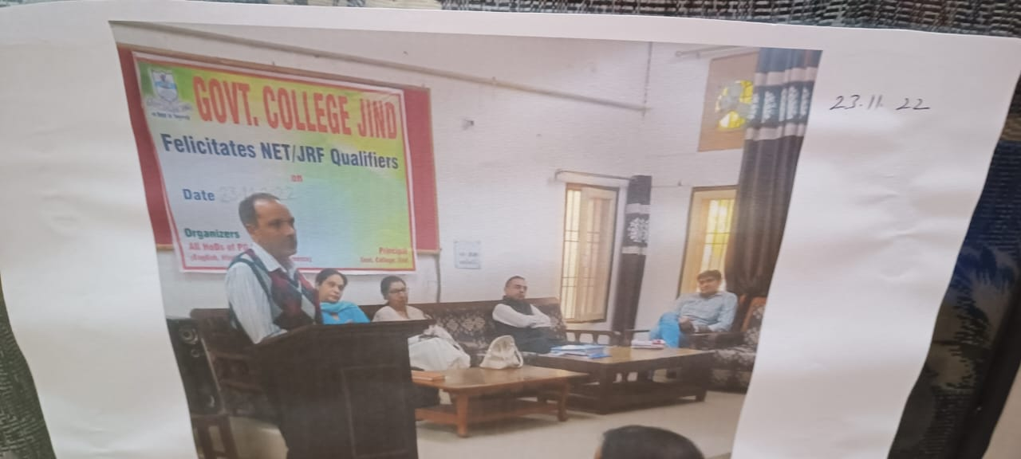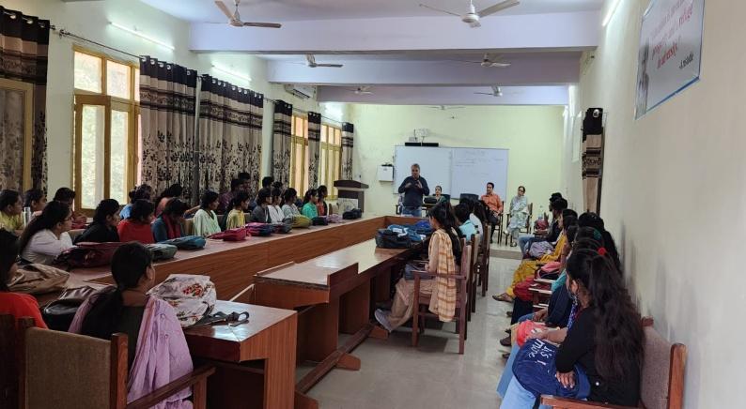
CONSOLIDATED STIPEND AND FREE BOOKS SCHEME FOR SC
CONVENOR: DR. NARENDER

SESSION | TOTAL STUDENTS | AMOUNT
2022-23 | 642 | 642*14000=8988000
Post Metric Scholarship for BC students
SESSION | TOTAL STUDENTS | AMOUNT
2022-2023 | 286 | 2288000

GENERAL MERIT SCHOLARSHIP (2022-23)
CONVENOR: DR. PREMPOONAM
YEAR | NAME OF SCHEME | NUMBER OF STUDENTS BENEFITTED BY GOVERNMENT SCHEME AND AMOUNT | NUMBER OF STUDENTS BENEFITTED BY INSTITUTION SCHEME AND AMOUNT | LINK TO RELEVENT DOCUMENT
2022-23 | CENTRAL SECTOR SCHEME FOR COLLEGE AND UNIVERSITY STUDENTS | 59 STUDENTS  (12,000 PER STUDENT) | NONE | NSP PORTAL
2022-23 | CENTRAL SECTOR SCHEME FOR COLLEGE AND UNIVERSITY STUDENTS RENEWAL | 52 STUDENTS (04, 20,000 PER STUDENT) (48, 10,000 PER STUDENT) | NONE | NSP PORTAL
2022-23 | POST MATRIC SCHOLARSHIP FOR MINORITY | 03 (UNDER PROCESS) | NONE | NSP PORTAL
2022-23 | STATE MERIT SCHOLARSHIP TO UG/PG STUDENTS | 35(UNDER PROCESS) | NONE | HARCHHATRAVRATTI  PORTAL
2022-23 | STATE MERIT SCHOLARSHIP TO UG GIRLS | 06(UNDER PROCESS) | NONE | HARCHHATRAVRATTI  PORTAL
2022-23 | HARYANA STATE MERITORIOUS INCENTIVE SCHEME | 45(UNDER PROCESS) | NONE | HARCHHATRAVRATTI  PORTAL
2022-23 | HARYANA STATE MERITORIOUS INCENTIVE SCHEME CBSE | 01(UNDER PROCESS) | NONE | HARCHHATRAVRATTI  PORTAL

  - NUMBER OF TEACHERS UNDERGOING ONLINE/FACE-TO-FACE FACULTY DEVELOPMENT PROGRAMMES (FDP) DURING THE YEAR 2022-23
Sr. No | Name of teacher who attended | Title of the program | Duration (from – to) (DD-MM-YYYY)
 | Gorav | Short Term FDP On NEP-2023 | 17-10-2022 to 25-10-2022
- 2 | Shiv Kumar | Short Term FDP On NEP-2023 | 27-10-2022 to 05-11-2022
 | Mukesh | Short Term FDP On NEP-2023 | 27-10-2022 to 05-11-2022
 | Munish Kumar | Short Term FDP On NEP-2023 | 21-12-2022 to 31-12-2022
 | Manoj Kumar | Short Term FDP On NEP-2023 | 21-12-2022 to 31-12-2022
 | Vishal Redhu | Short Term FDP On NEP-2023 | 21-12-2022 to 31-12-2022
 | Mukesh Kumari | Short Term FDP On NEP-2023 | 21-12-2022 to 31-12-2022
 | Prem Poonam | Short Term FDP On NEP-2023 | 21-12-2022 to 31-12-2022
 | Yashwanti | Short Term FDP On NEP-2023 | 21-12-2022 to 31-12-2022
 | ravi Kumar Garg | Short Term FDP On NEP-2023 | 21-12-2022 to 31-12-2022
 | Kamaljeet | Short Term FDP On NEP-2023 | 21-12-2022 to 31-12-2022
 | Satish Kumar | Short Term FDP On NEP-2023 | 21-12-2022 to 31-12-2022
 | Aman | Short Term FDP On NEP-2023 | 21-12-2022 to 31-12-2022
 | Sonu | Short Term FDP On NEP-2023 | 21-12-2022 to 31-12-2022
 | Narender Kumar | Short Term FDP On NEP-2023 | 21-12-2022 to 31-12-2022
 | Shamsher | Short Term FDP On NEP-2023 | 21-12-2022 to 31-12-2022
 | Satyawan | Short Term FDP On NEP-2023 | 21-12-2022 to 31-12-2022
 | Savita Poonia | Short Term FDP On NEP-2023 | 20-01-2023 to 29-01-2023
 | Pushpa | Short Term FDP On NEP-2023 | 20-01-2023 to 29-01-2023
 | Rajkamal | Short Term FDP On NEP-2023 | 20-01-2023 to 29-01-2023
 | Reetu | Short Term FDP On NEP-2023 | 20-01-2023 to 29-01-2023
 | Nisha Pruthi | Short Term FDP On NEP-2023 | 20-01-2023 to 29-01-2023
 | Satish Kumar | Short Term FDP On NEP-2023 | 08-05-2023 to 16-05-2023
 | Anu | Short Term FDP On NEP-2023 | 08-05-2023 to 16-05-2023
 | Anjana Dhawan | Short Term FDP On NEP-2023 | 08-05-2023 to 16-05-2023
 | Pushpa Rani | Short Term FDP On NEP-2023 | 08-05-2023 to 16-05-2023
 | Suman | Short Term FDP On NEP-2023 | 08-05-2023 to 16-05-2023
 | Seema Rani | Short Term FDP On NEP-2023 | 08-05-2023 to 16-05-2023
 | Vikram Singh | Short Term FDP On NEP-2023 | 08-05-2023 to 16-05-2023
 | Dr. Krishan Kumar | Short Term FDP On NEP-2023 | 08-05-2023 to 16-05-2023
 | Poonam | Short Term FDP On NEP-2023 | 08-05-2023 to 16-05-2023
 | Narender Kumar | Short Term FDP On NEP-2023 | 08-05-2023 to 16-05-2023
 | Sunita Kumari | Short Term FDP On NEP-2023 | 08-05-2023 to 16-05-2023
 | Ankit | Short Term FDP On NEP-2023 | 08-05-2023 to 16-05-2023
 | Rahul | Short Term FDP On NEP-2023 | 08-05-2023 to 16-05-2023
 | Promila | Short Term FDP On NEP-2023 | 08-05-2023 to 16-05-2023
 | Chanchal Sharma | Short Term FDP On NEP-2023 | 08-05-2023 to 16-05-2023
 | Ritu | Short Term FDP On NEP-2023 | 08-05-2023 to 16-05-2023
 | Pargati | Short Term FDP On NEP-2023 | 08-05-2023 to 16-05-2023
 | Jyoti | Short Term FDP On NEP-2023 | 08-05-2023 to 16-05-2023
 | Renu Devi | Short Term FDP On NEP-2023 | 08-05-2023 to 16-05-2023
 | Seema Redhu | Short Term FDP On NEP-2023 | 08-05-2023 to 16-05-2023
 | Monika Jaglan | Short Term FDP On NEP-2023 | 08-05-2023 to 16-05-2023
 | Vijaypal | Short Term FDP On NEP-2023 | 08-05-2023 to 16-05-2023
 | Bal Krishan | Short Term FDP On NEP-2023 | 08-05-2023 to 16-05-2023
 | Reena Rani | Short Term FDP On NEP-2023 | 08-05-2023 to 16-05-2023
 | Rachna | Short Term FDP On NEP-2023 | 08-05-2023 to 16-05-2023
 | Yashpal | Short Term FDP On NEP-2023 | 08-05-2023 to 16-05-2023
 | Ashish | Short Term FDP On NEP-2023 | 08-05-2023 to 16-05-2023
 | Anjali Sharm | Short Term FDP On NEP-2023 | 08-05-2023 to 16-05-2023
 | Nitu | Short Term FDP On NEP-2023 | 08-05-2023 to 16-05-2023
 | Sushma Rani | Short Term FDP On NEP-2023 | 08-05-2023 to 16-05-2023
 | Poonam Devi | Short Term FDP On NEP-2023 | 08-05-2023 to 16-05-2023
 | Monika | Short Term FDP On NEP-2023 | 08-05-2023 to 16-05-2023
 | Savita Rani | Short Term FDP On NEP-2023 | 08-05-2023 to 16-05-2023
 | Ajay Singh | Short Term FDP On NEP-2023 | 08-05-2023 to 16-05-2023
 | Virender Kumar | Short Term FDP On NEP-2023 | 08-05-2023 to 16-05-2023
 | Poonam | Short Term FDP On NEP-2023 | 08-05-2023 to 16-05-2023
 | Satparkash | Short Term FDP On NEP-2023 | 08-05-2023 to 16-05-2023
 | Savita Duhan | Short Term FDP On NEP-2023 | 08-05-2023 to 16-05-2023
 | Usha | Short Term FDP On NEP-2023 | 08-05-2023 to 16-05-2023
 | Priti | Short Term FDP On NEP-2023 | 08-05-2023 to 16-05-2023
 | Bhupender | Short Term FDP On NEP-2023 | 08-05-2023 to 16-05-2023
 | Sharmila | Short Term FDP On NEP-2023 | 08-05-2023 to 16-05-2023
 | Naveen | Short Term FDP On NEP-2023 | 08-05-2023 to 16-05-2023
 | Bhoop Singh | Short Term FDP On NEP-2023 | 12.6.2023 to 20.6.2023
 | Randhir Singh | Short Term FDP On NEP-2023 | 12.6.2023 to 20.6.2023
 | Jyoti Sheoran | Short Term FDP On NEP-2023 | 12.6.2023 to 20.6.2023
 | Santosh | Short Term FDP On NEP-2023 | 12.6.2023 to 20.6.2023
 | Sushila Devi | Short Term FDP On NEP-2023 | 12.6.2023 to 20.6.2023
 | Kamlesh | Short Term FDP On NEP-2023 | 12.6.2023 to 20.6.2023
 | Renu Jakhar | Short Term FDP On NEP-2023 | 12.6.2023 to 20.6.2023
 | Kiran bala | Short Term FDP On NEP-2023 | 12.6.2023 to 20.6.2023
 | Komal | Short Term FDP On NEP-2023 | 12.6.2023 to 20.6.2023
 | Suman Rani | Short Term FDP On NEP-2023 | 12.6.2023 to 20.6.2023
 | Jyoti | Short Term FDP On NEP-2023 | 12.6.2023 to 20.6.2023
 | Sunita devi | Short Term FDP On NEP-2023 | 12.6.2023 to 20.6.2023
 | Reena Devi | Short Term FDP On NEP-2023 | 12.6.2023 to 20.6.2023
 | Mannu arya | Short Term FDP On NEP-2023 | 12.6.2023 to 20.6.2023
 | Varun Kumar | Short Term FDP On NEP-2023 | 12.6.2023 to 20.6.2023
 | Pankaj Batra | Work shop | 7.12.2022
 | Pankaj Batra | Orientation Programme | 21.10.2022
 | Vishal Redhu | Seminar | 17.2.2023
 | Munish Kumar | IP Training Programme | 20.4.2023
 | Munish Kumar | Workshop | 25.11.2022
 | Munish Kumar | Seminar | 11.2.2023
 | Gorav | FDP | 6.8.2022 to 12.8.2022
 | Ravi Kumar Garg | NNMRS Course Sponsred by ISRO | 15.5.2023 to 7.7.2023
 | Kamaljeet | Workshop | 22.9.2022 to 28.9.2022
 | Rajkamal | Seminar | 10.9.2022
 | Rajkamal | Seminar | 19.11.2022
 | Rajkamal | Seminar | 17.2.2023
 | Rajkamal | Seminar | 20.2.2023
 | Satish Kumar | Refresher Course | 27.1.2023 to 9.2.2023
 | Monika Singla | Refresher Course | 9.1.2023 to 21.1.2023

