Annual Activity Report of IQAC for Session 2021-22
- The cell organized 1ST Dose COVID-19 vaccination camp for the faculty members and students of the institute on dated 23rd August, 2021. Around 150 faculty members and students got there COVID-19 first dose vaccination. Sh. Raj Kumar, District President, BJP and Dr. Rajesh Bhola, Dy. CMO, civil Hospital, Jind attended the event as Chief Guest & special Guest and planted saplings.

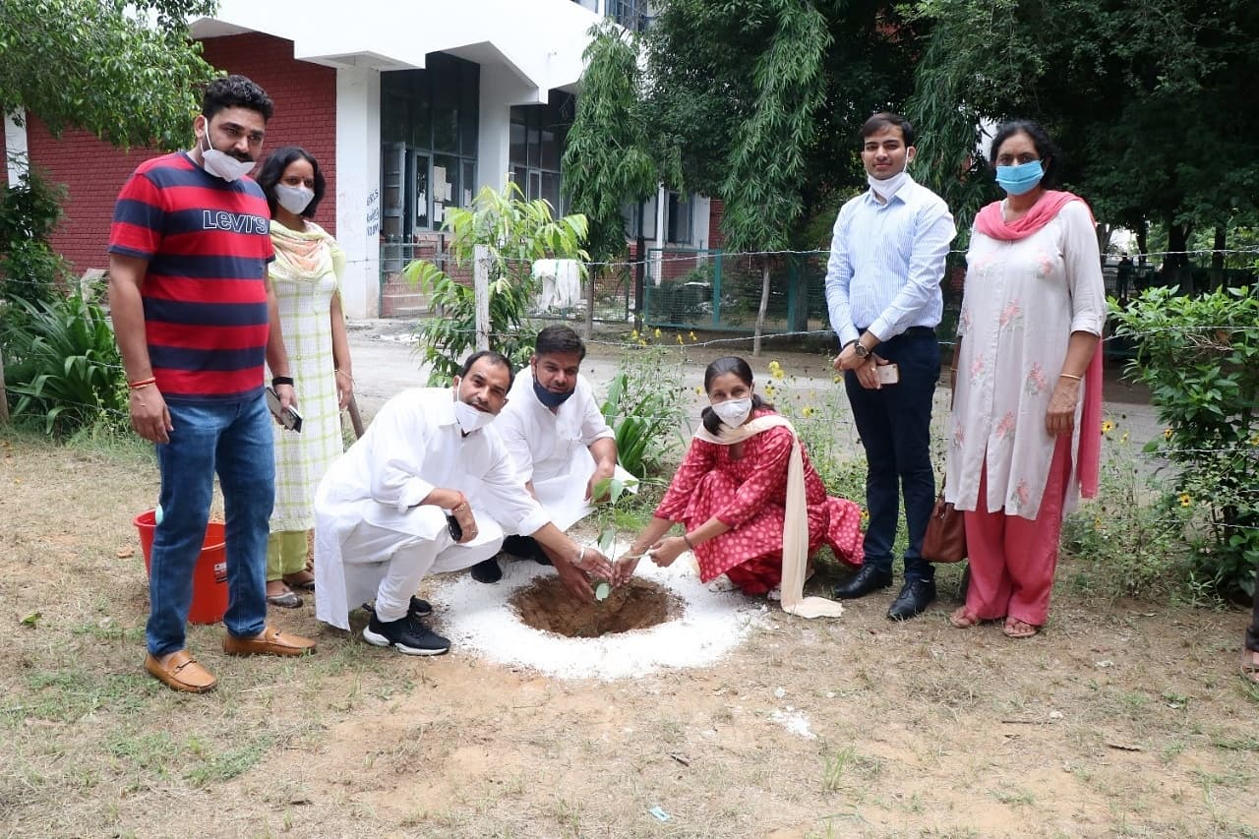
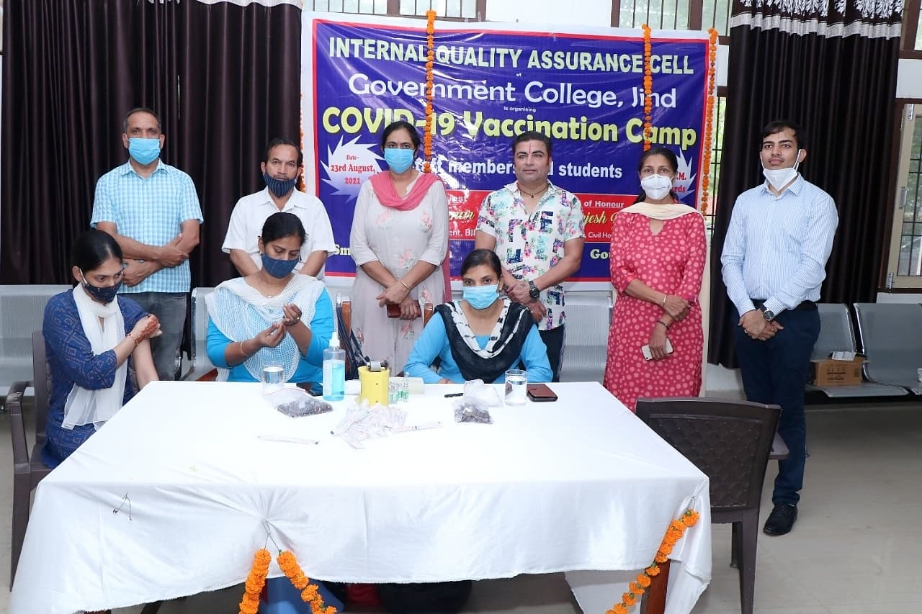
- The cell organized 2nd Dose COVID-19 vaccination camp for the faculty members and students of the institute on dated 27th December, 2021. Around 210 faculty members and students got there COVID-19 second dose vaccination.

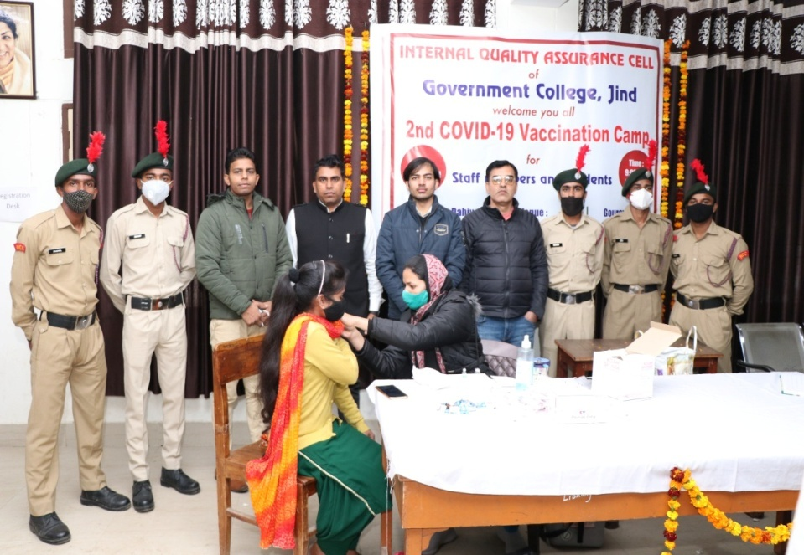

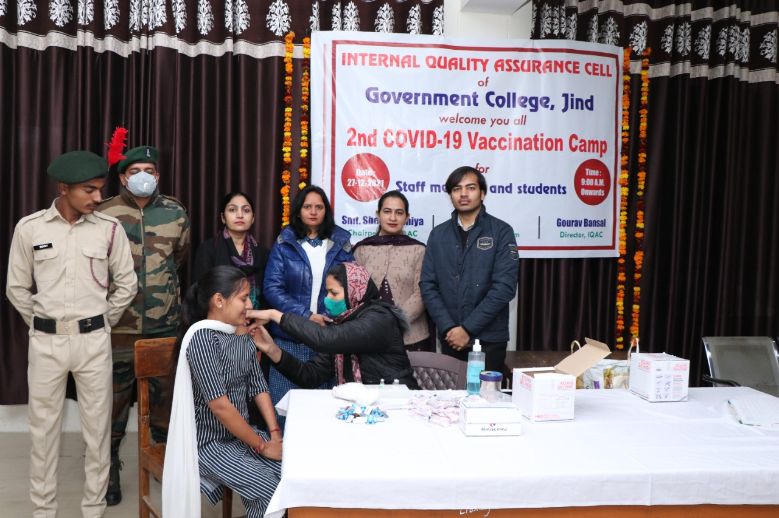
- The cell organized online two week faculty development program/interdisciplinary refresher course on ‘ ADVANCE RESEARCH METHODOLOGY’ in collaboration with Teaching learning centre, Ramanujan College, University of Delhi, New Delhi from dated 22 April to 6 May 2022. 461 Faculty members, research scholars and post graduate students across the Nation got their registration and successfully completed the course. This is the institutional first MOU signed with TLC Ramanujan College, New Delhi for Research.
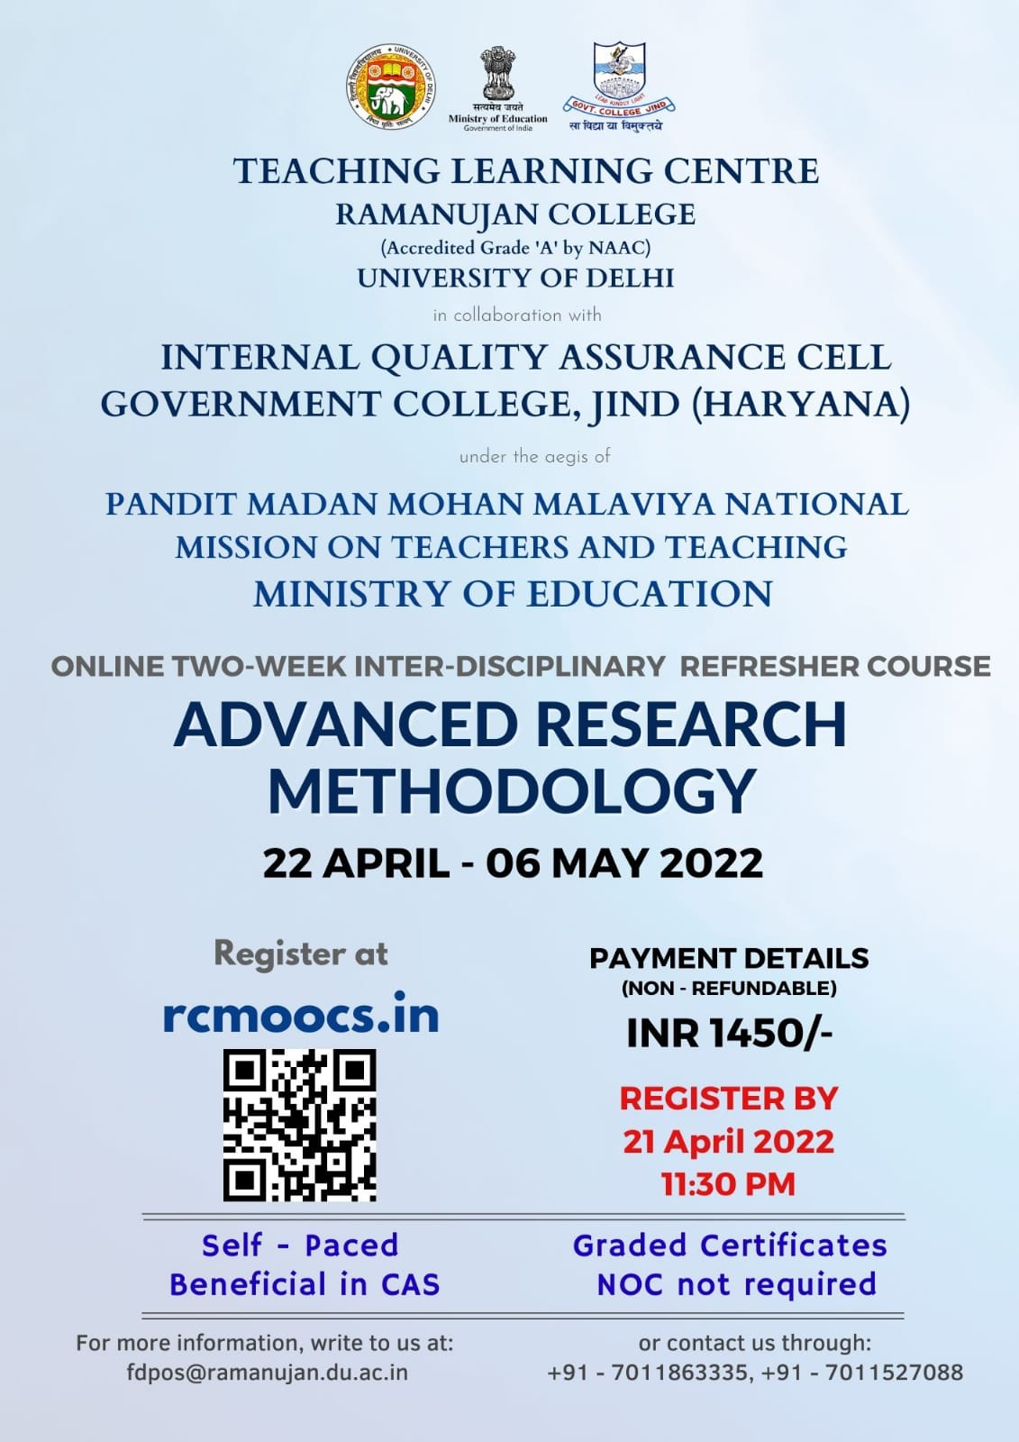

- The cell celebrated Hypertension day in collaboration with women cell and Red Cross society of the college on dated 17.05.2022. On this occasion N C D unit of the Civil Hospital Jind visited the institution and vitals of around 200 students and faculty members were checked. Dr. Ramesh Panchal, District Nodal officer for the Hypertension Day guided the students about causes and measures to prevention our self from Hypertension.

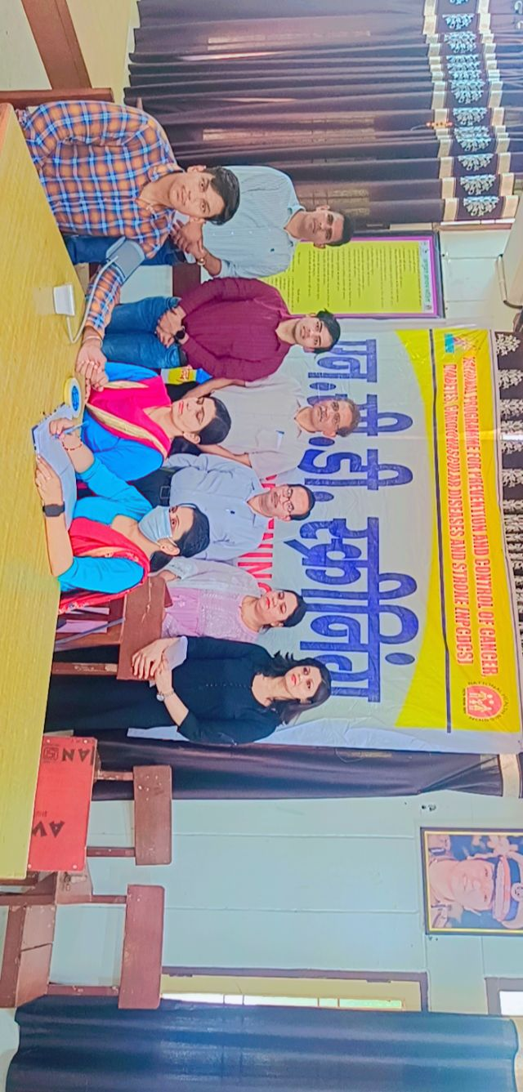

- The cell organized Blood donation camp in collaboration with Inner wheel club Jind on dated 19 May, 2022. Red Cross team from the National headquarters New Delhi facilitated the camp and collected 88 units. Smt. Rajnish Jain, President of Inner wheel club, Jind and Col. Anurag Mehra, commanding officer, 15- Haryana Battalion visited the camp as guest.
